Global Warming

Before the news was dominated by Covid 19, you might have heard about the threat of global warming. This means that the world is slowly heating up and scientists believe that this will have serious consequences for our world.
As part of our work on solids, liquids and gases, we will be learning about global warming. Go now to the PowerPoint to learn more.

Activity

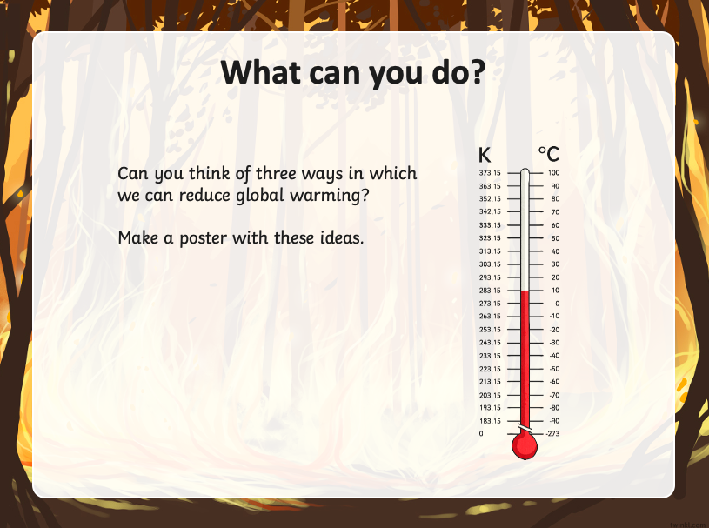

If you need help with ideas, this website is great:
https://scholarpack9.co.uk/fernhouseenfield/main/login/login_form?came_from=https://scholarpack9.co.uk/fernhouseenfield/main/index_html&retry=&disable_cookie_login__=1

Remember, you can email me a picture of your finished poster to our class email address.

