Maths - Addition and Subtraction

This week, our maths focus is addition and subtraction.

You might feel really confident about adding and subtracting or you might find it difficult, so there are different challenges here. Choose one that suits you. As always, more chillies mean the activity is more difficult.

Activity 1 

Watch the addition and subtraction videos on BBC Bitesize:

https://www.bbc.co.uk/bitesize/topics/zwv39j6

Use whatever objects you have at home to complete the questions, pasta, coins, small pebbles etc are all useful counting objects. The Base 10 pictures from last week’s work can also help you.

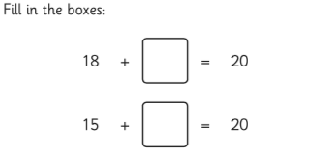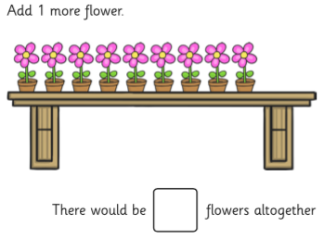

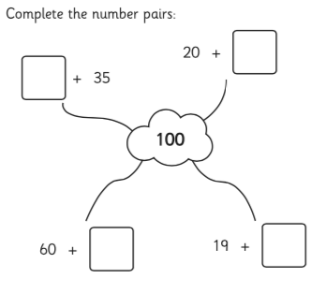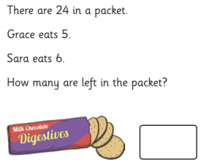
Activity 2 

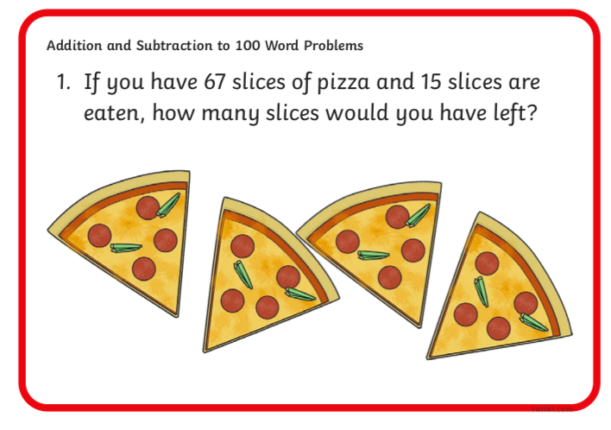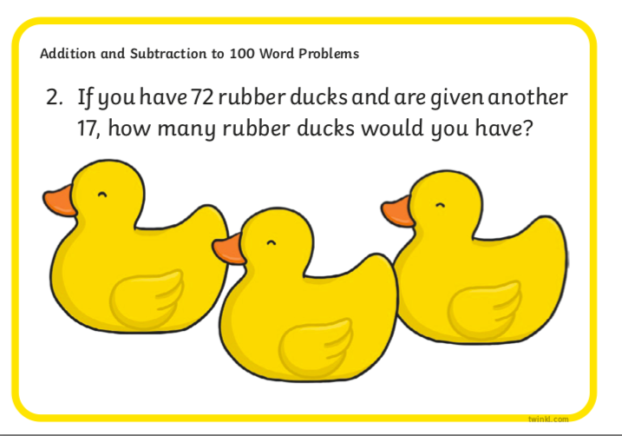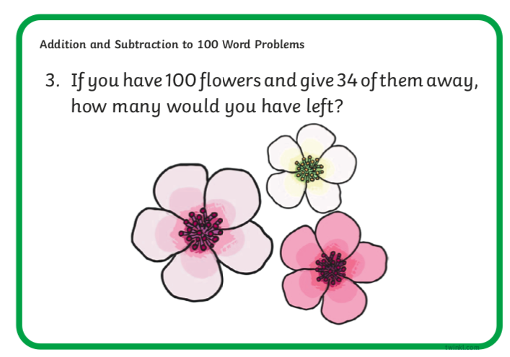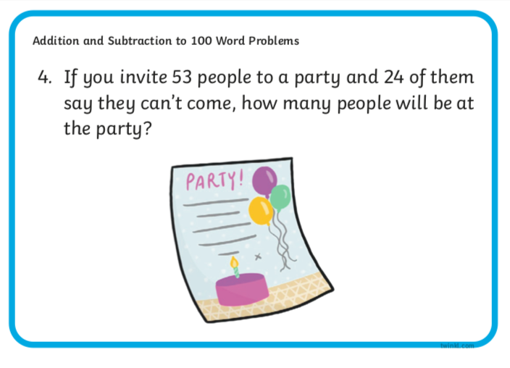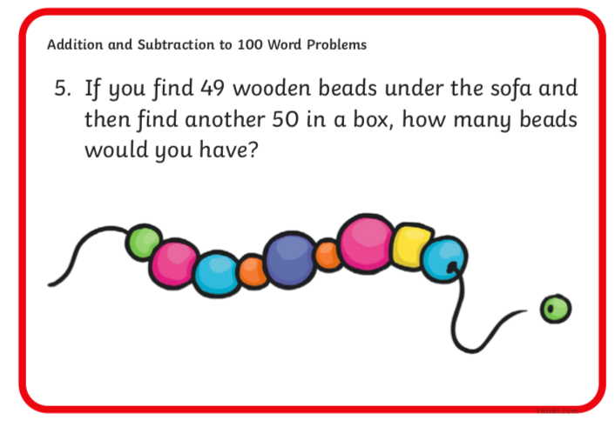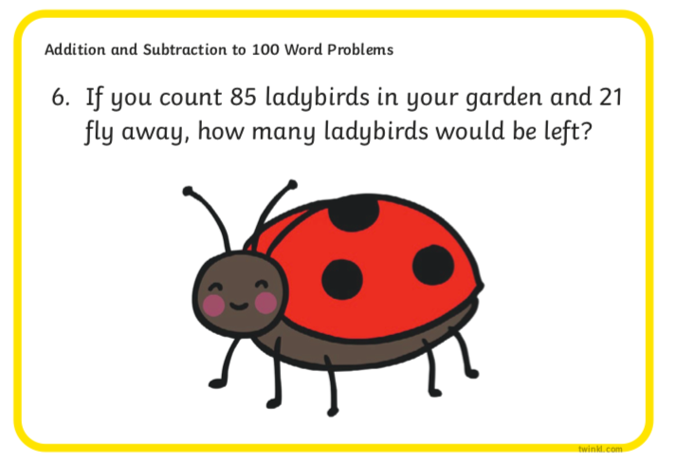

Activity 3

Watch the BBC Bitesize videos on column addition and subtraction. Then try to solve the calculations using the column method:

Column Addition:

https://www.bbc.co.uk/bitesize/topics/zy2mn39/articles/z3kmrwx

Column Subtraction:

https://www.bbc.co.uk/bitesize/topics/zy2mn39/articles/zc78srd

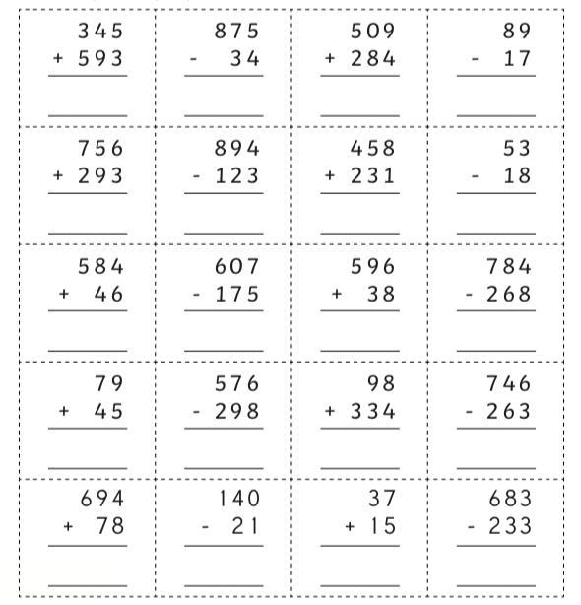

Activity 4

If you are confident in using the column method to add and subtract, have a go at solving these word problems using column addition or subtraction. They are tricky because you need to do more than one step to solve them!


