Adverbs

Adverbs are words that are used to describe a verb. They sometimes, but not always, end with ‘-ly’. Here are some examples:
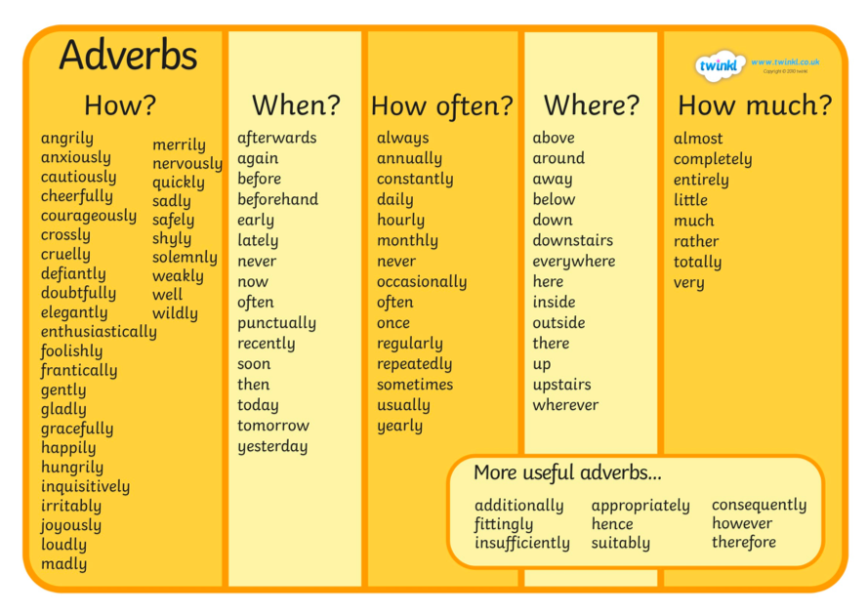

Look at the adverbs PowerPoint to find out more. Then complete the task below.



