Being respectful of other people’s ideas and opinions.

You will remember this activity from last week. This week we have new discussion starters. Remember there are different ways to use these, try to choose a different option than last week.

You can use the conversation starters in different ways:

- You could talk to someone at home about the subject. Do you both agree and if not, can you disagree in a respectful way?
- Write down your opinion about one of the subjects.
- Choose one of the subjects, think about your own opinion and then write down the opposite opinion to your own. (This is a really tricky thing to do but really helps you to understand others).

Conversation starters

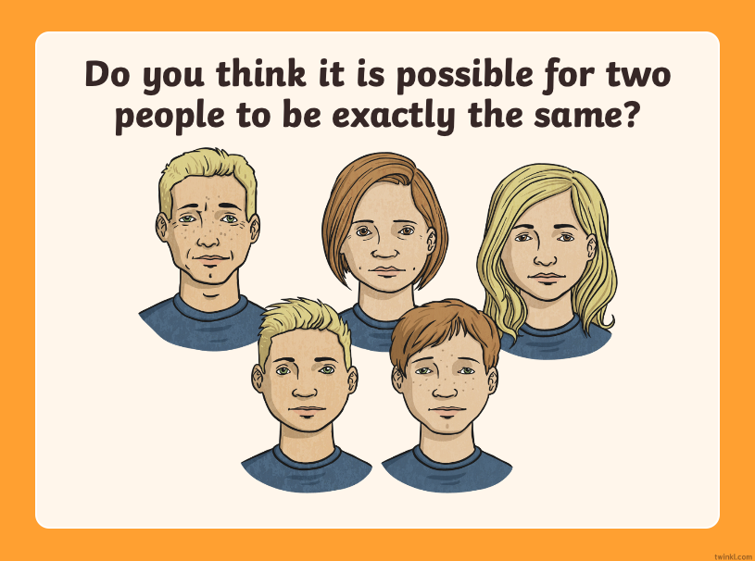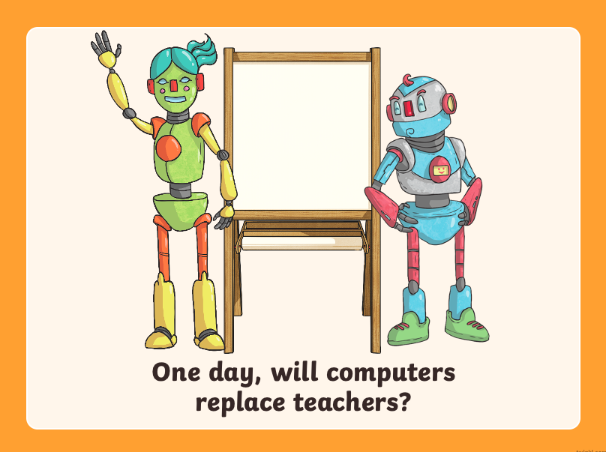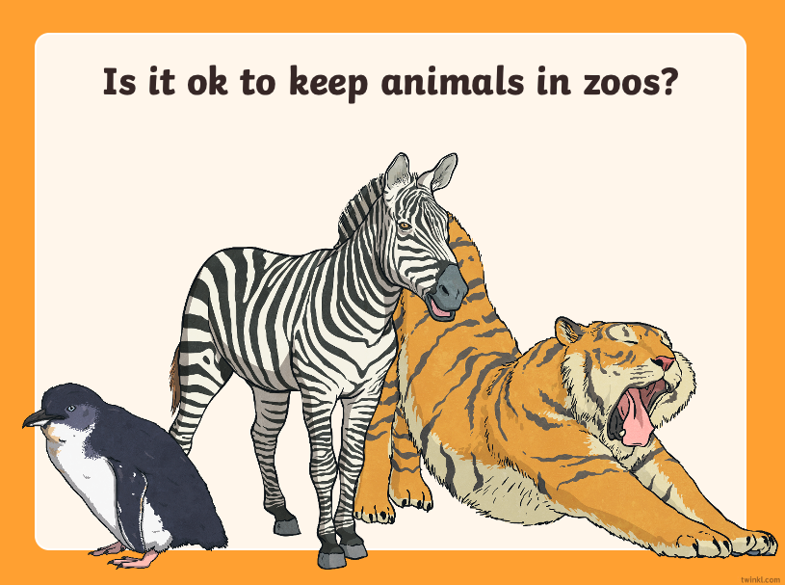

Remember that you can share your work with me by using our class email address.

