How do different animals breathe?

Last week, we learnt how humans breathe. Not all animals breathe in the same way, so today we will look at different animals and how they breathe.

Watch the video and complete the quiz:

How do different animals breathe?

Draw a poster to show how the three different animals breathe:

A fish 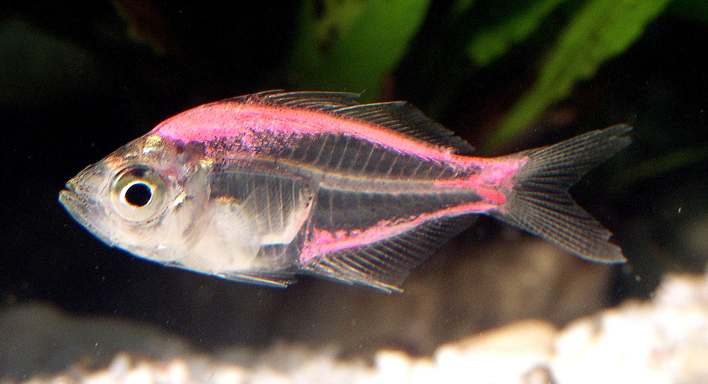
A frog 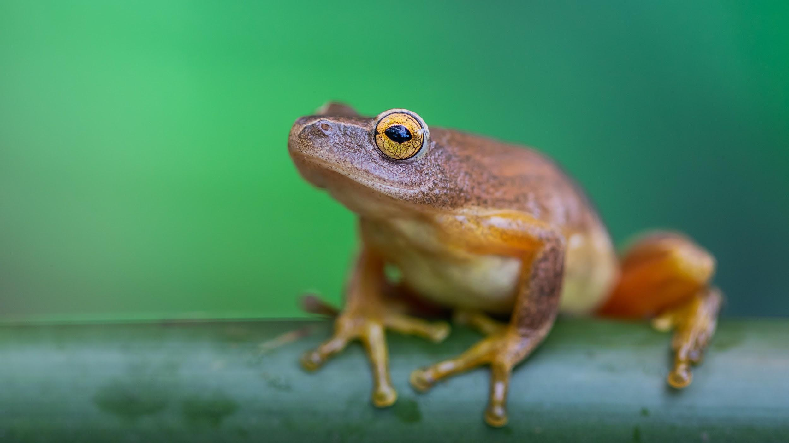
A grasshopper 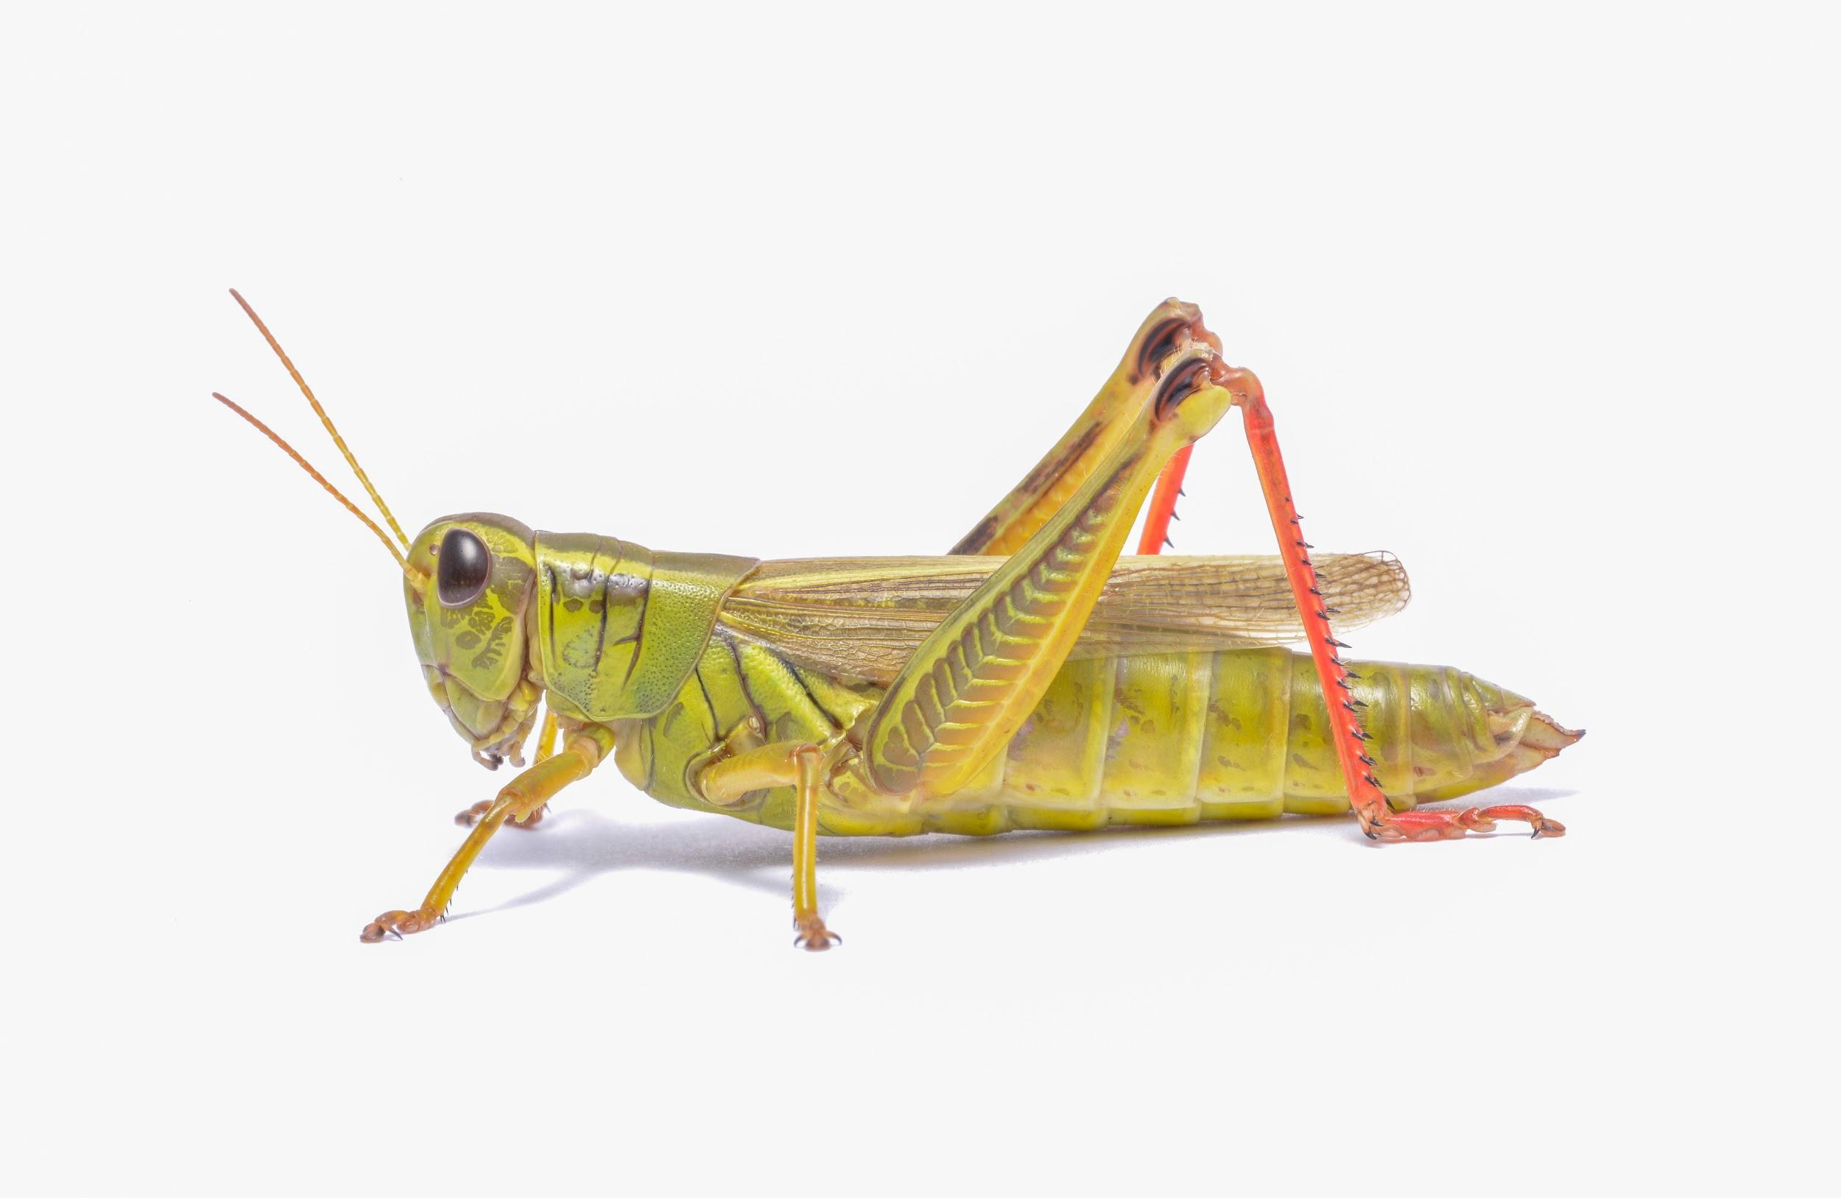

Remember, you can email pictures of your work to me using our class email address!

