Place Value

This week, we are solving problems involving place value.

To start at the beginning with place value, use this BBC Bitesize page link:

https://www.bbc.co.uk/bitesize/topics/z8sfr82/articles/zw4g2nb

If you are already quite confident with place value, take a look at the Place Value PowerPoint to learn more.

Now, choose from the activities below. As always, the more chillies, the more difficult the challenge. You can choose the one that is right for you.

The 0 - 9 number cards and the base 10 equipment pictures might help you to answer the questions.

Remember that you can email any completed work to our class email address.
Activity 1 

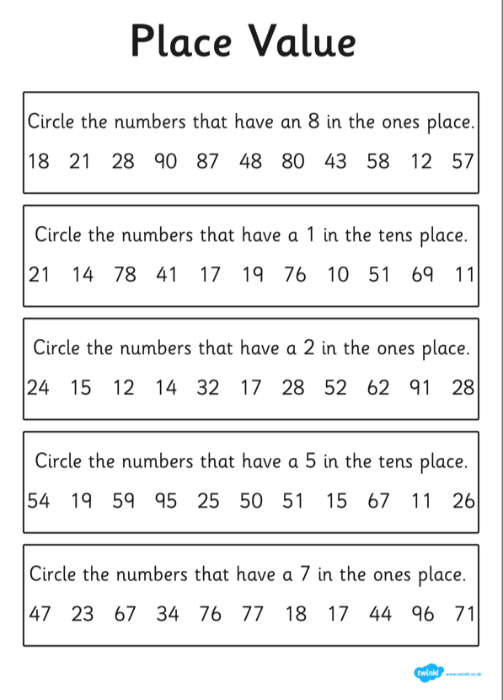

Activity 2
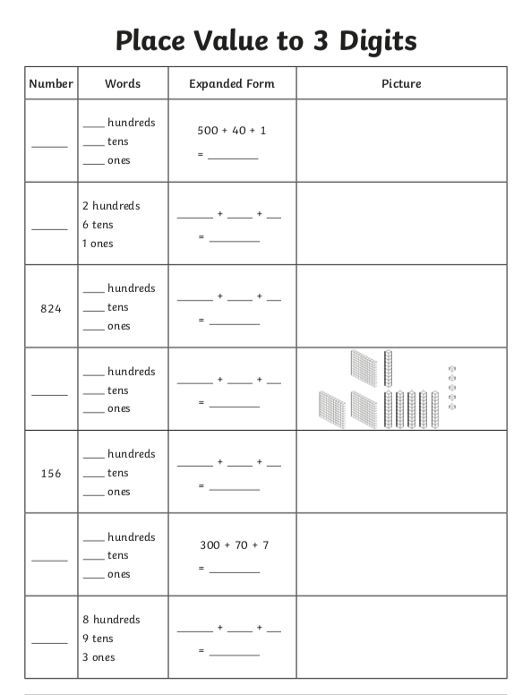

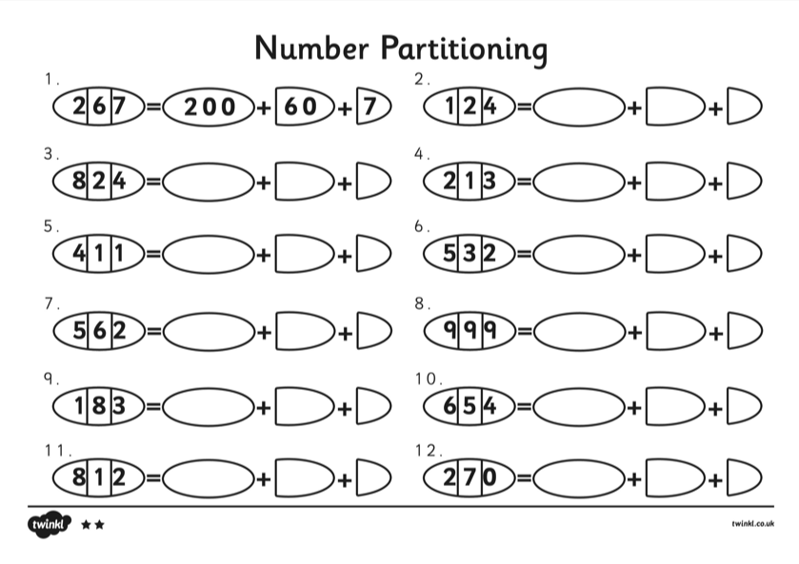

Activity 3



