Apostrophes for Contraction

You can use an apostrophe in some words to show that you have left letters out. In this way we can put two words together to create one, shorter word. For example, instead of writing ‘you are’, you can write ‘you’re’. Watch the video to find out more:

How to use apostrophes in contractions.

Next, try the activities.

Activity 1:

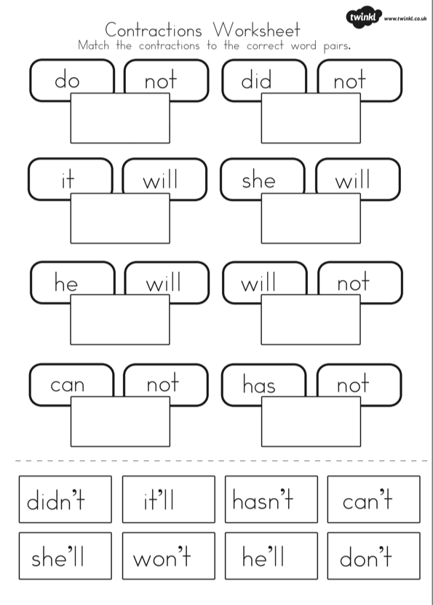

Activity 2:



