Being respectful of other people’s ideas and opinions.

Look at the conversation starters on the next page. They do not have a right or wrong answer but different people will have different views on the topics. Throughout your life you will meet people who hold different ideas and opinions to you. Knowing how to be respectful of others, whilst sharing your own opinions, is a really important skill.

You can use the conversation starters in different ways:

- You could talk to someone at home about the subject. Do you both agree and if not, can you disagree in a respectful way?
- Write down your opinion about one of the subjects.
- Choose one of the subjects, think about your own opinion and then write down the opposite opinion to your own. (This is a really tricky thing to do but really helps you to understand others).

Conversation starters

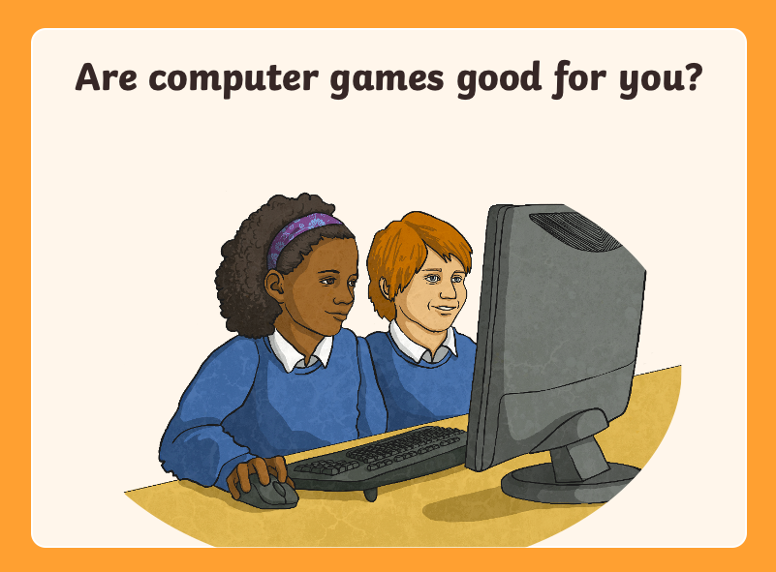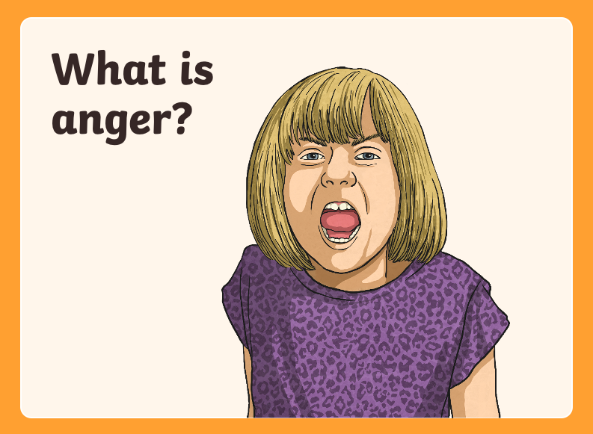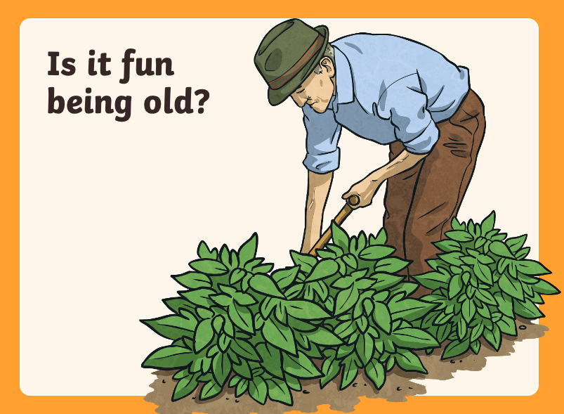

Remember that you can share your work with me by using our class email address.

