What is a pronoun?

Click here to find out about pronouns:
What is a pronoun?
Then, try the activity below to check your understanding.

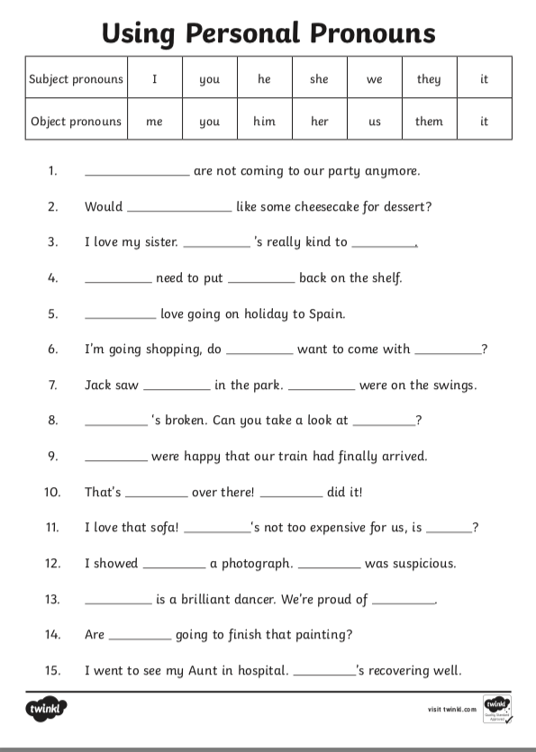

If you understand pronouns, try the challenge:

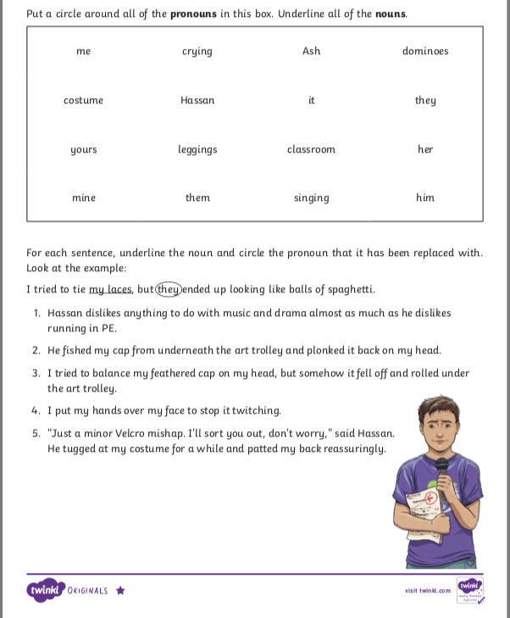

Remember, you can email pictures of your work to me using our class email address!

