Music - The Legend of King Arthur

Watch the video to learn the story of King Arthur:

https://safeyoutube.net/w/qXbn

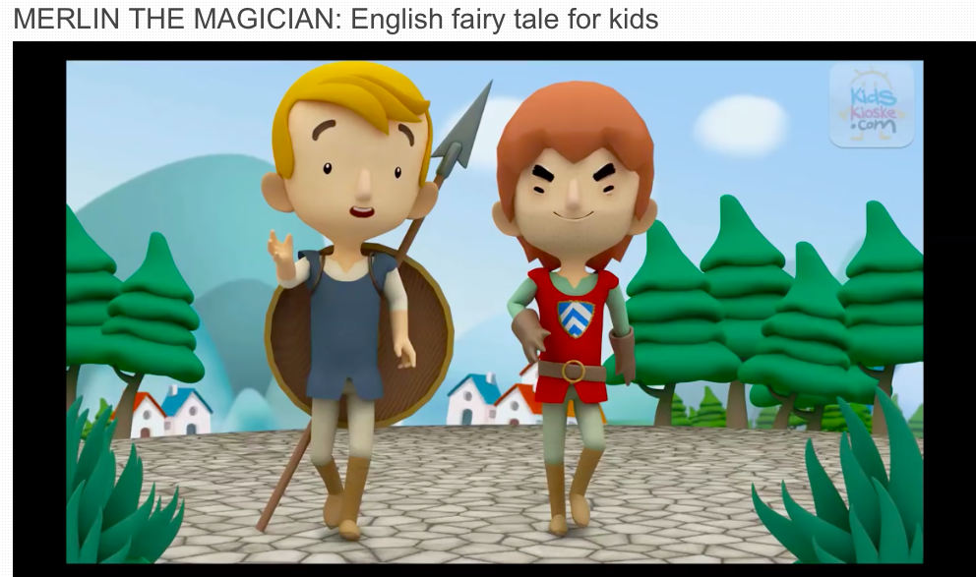

This is another example of a myth or legend.
We will continue to learn about musical structure and texture through the theme of Myths and Legends.
Listen to this English folk song called ‘When Good King Arthur’. This song is about the legend of King Arthur. I have attached the lyrics on the next page.
https://safeyoutube.net/w/Iydn

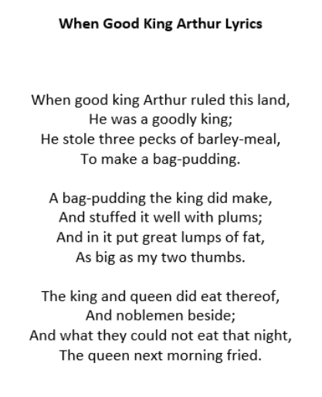
Over the next 2 weeks, we are going to think about the structure of this piece of music using specific vocabulary. Can you use a dictionary, the internet or an adult at home to help you to find the meaning of these words?
Instrumental -
Verse -
Chorus -

