How do plants make food?

Watch the video below to find out about photosynthesis:

https://www.youtube.com/watch?v=UPBMG5EYydo

Can you correctly label the plant diagram using the given words?

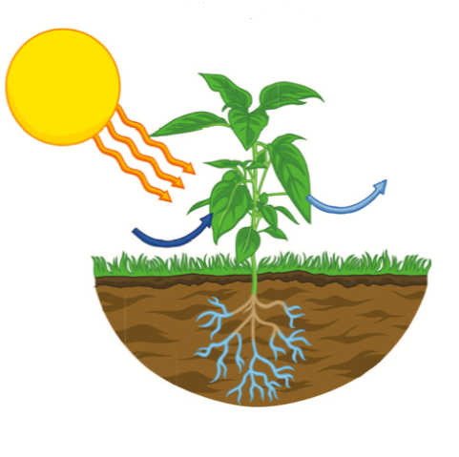

Carbon dioxide | light | oxygen

