How do humans breathe?

Watch the video on BBC Bitesize to find out about how we breathe.

https://www.bbc.co.uk/bitesize/topics/zv9qhyc/articles/zdfs47h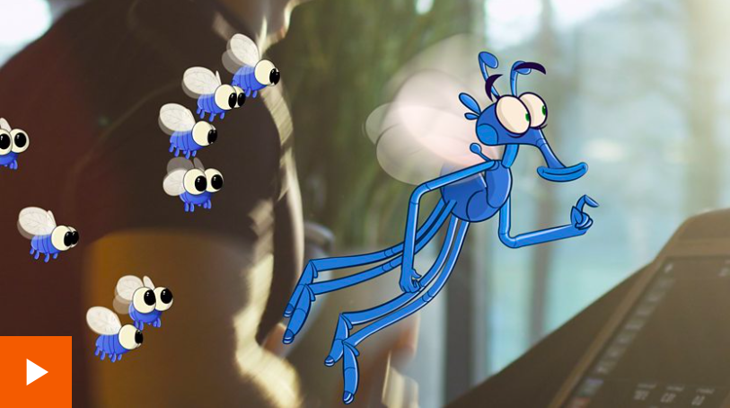

Oxygen and Carbon Dioxide are gases. As you know from the work you did on different habitable planets in your Space topic, oxygen is essential for human life. It is also essential for fire.

Watch the Lesson Presentation about the scientists who discovered oxygen and then come back here to complete the activity.



