Music - St.George and the Dragon

Watch the video to learn the story of St. George and the Dragon:

https://safeyoutube.net/w/bXbn

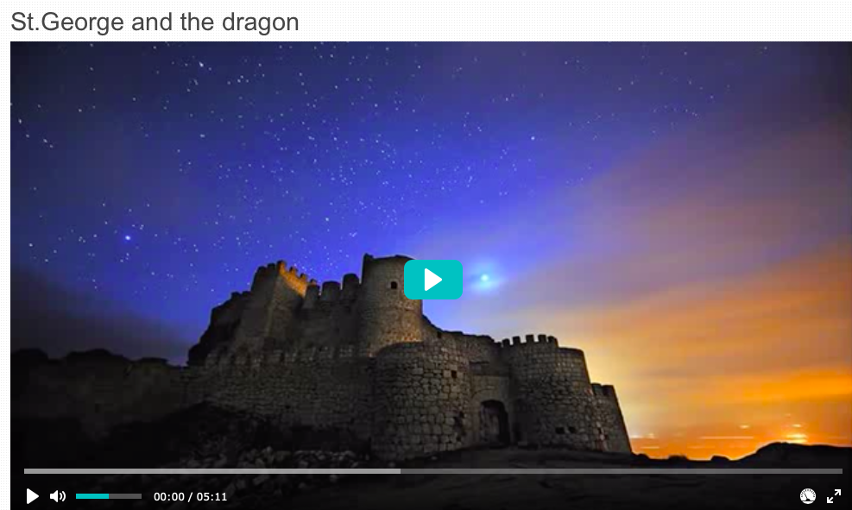
What did you think of the story? Have you heard it before? You may have heard a different version of it and that this is common with myths, legends and traditional tales.
When stories were first told a long time ago, people made slight changes to it as they passed it on, much like chinese whispers. This leads to slightly different versions of the same story.
We’re going to be learning about musical structure and texture through the theme of Myths and Legends.
Listen to this traditional English folk song called ‘St. George’
https://safeyoutube.net/w/M7cn

Can you answer these questions about the song?
- What kind of instruments can you hear? (Traditional string instruments, accordion and tambourine)
- What kind of structure does it have? Does it repeat? Is there a chorus that is repeated?
- Is the texture thick or thin? Are there lots of different instruments playing at the same time or do they take turns? Are there different ‘layers’ to the music?

