Solids, Liquids and Gases
Watch the BBC Bitesize video:

https://www.bbc.co.uk/bitesize/topics/zkgg87h/articles/z9ck9qt
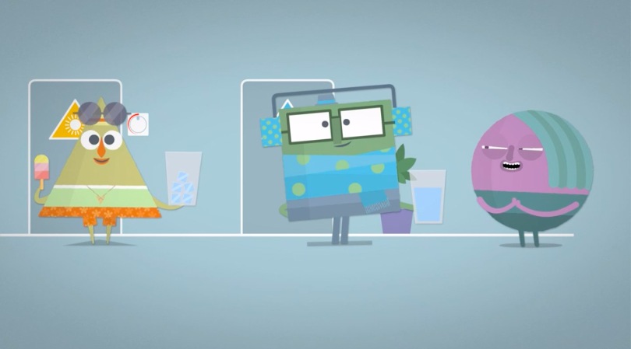
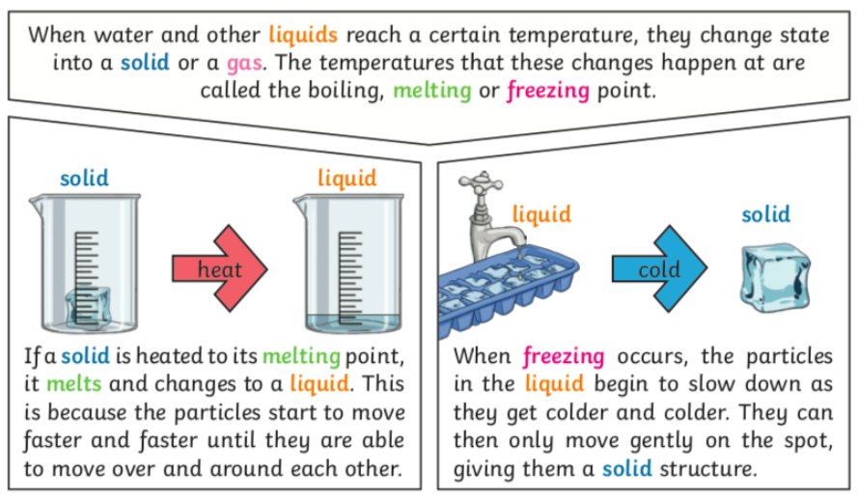
Before you try any of these activities, check with a grown up at home.
When you freeze water it changes from a liquid to a solid. When you heat an ice cube, it changes from a solid to a liquid. The change is reversible.

Your task is to try to change the state of different things by boiling and freezing or melting. You must be very careful when heating things or freezing things. Don’t try any of these activities on your own and make sure an adult has given you permission!

What happens to these things if you heat them up or cool them down?

- cheese
- chocolate
- egg
- orange juice
- milk
- pasta
- any fruit of your choice

Think about whether the item is a solid liquid or gas. Does the state of matter change when you heat the item? Does it change when you cool or freeze the item? If it has changed, can you reverse the changes by doing the opposite?

