Watch the Newsround video all about why chocolate eggs are given at Easter time:

https://www.bbc.co.uk/newsround/17597617


Eggs symbolise new life and rebirth and remind Christians of Jesus’ rebirth.

Task

Empathy means: To ‘put yourself in someone else’s shoe’. To be able to understand how someone else thinks and what they feel.

Use empathy to answer the question below.
You could tell someone your answer, draw a picture and label it or write your answer in sentences.

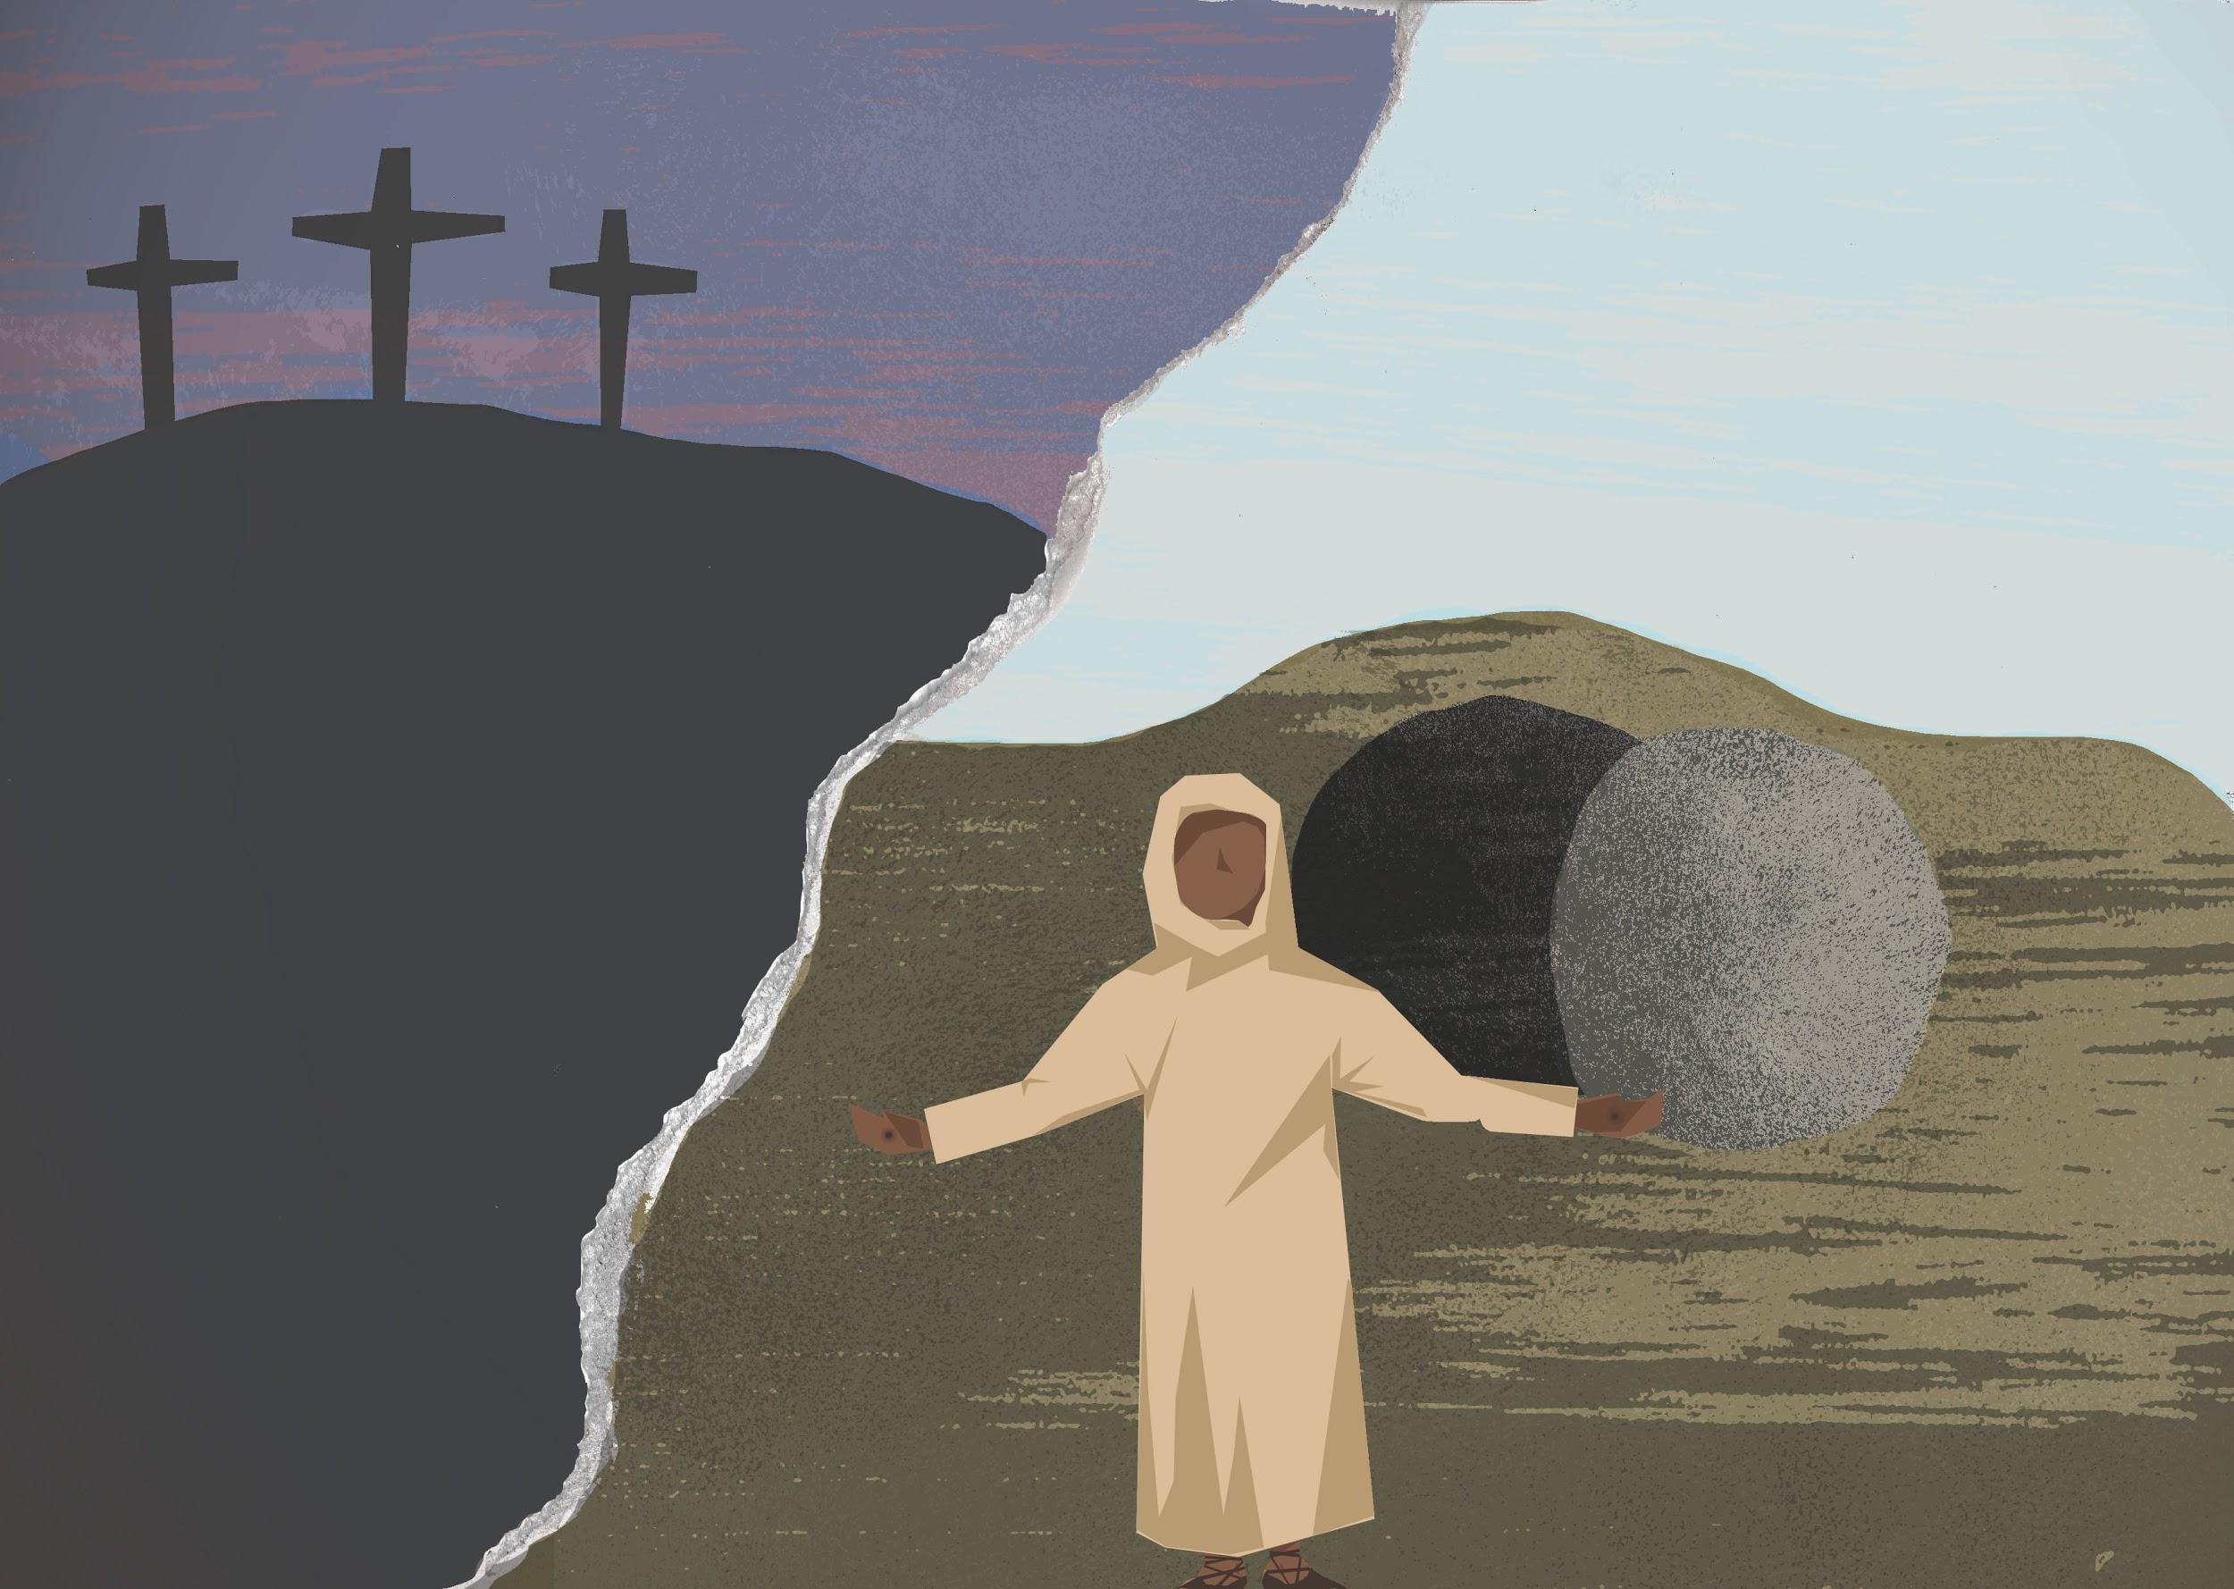
How do you think the Easter story gives Christians hope and comfort?

