PSHE

In PSHE this term we will be learning about our place in the wider world. This week, we will be learning about the human impact on the environment.

Watch the BBC Bitesize video:

https://www.bbc.co.uk/bitesize/topics/zp22pv4/articles/z2md82p
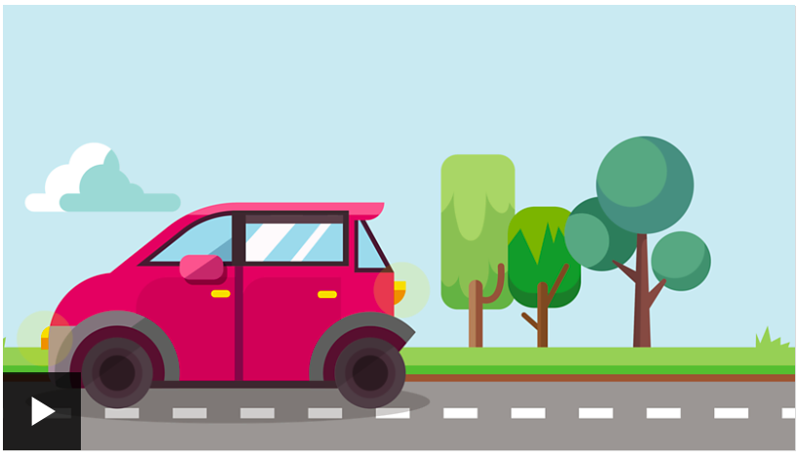

Next, complete the activity on the same page:
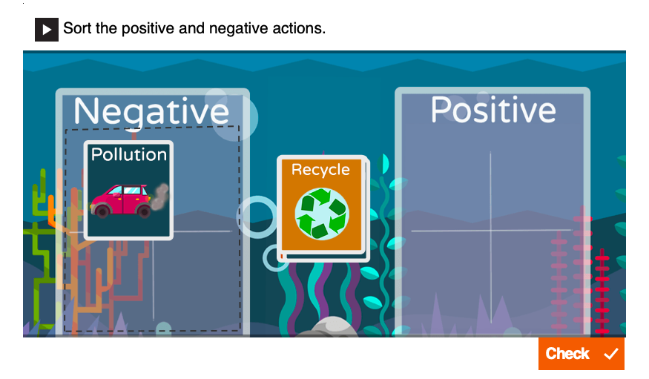

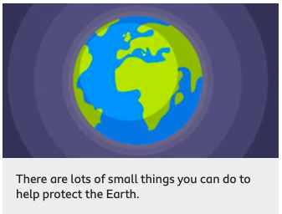

Can you think of some ways you could protect the Earth from your own home?
You could tell someone else about them, make a poster or even record a video.

