Fractions

Watch the BBC Bitesize video on this page:

https://www.bbc.co.uk/bitesize/topics/z3rbg82/articles/zt7nfrd



What is a Unit Fraction?
A unit fraction is a fraction where the numerator is 1 and the denominator is a whole number. It represents one shaded part of all the equal parts of the whole. In general, a fraction's denominator tells us how many parts we are breaking the fraction's numerator into.
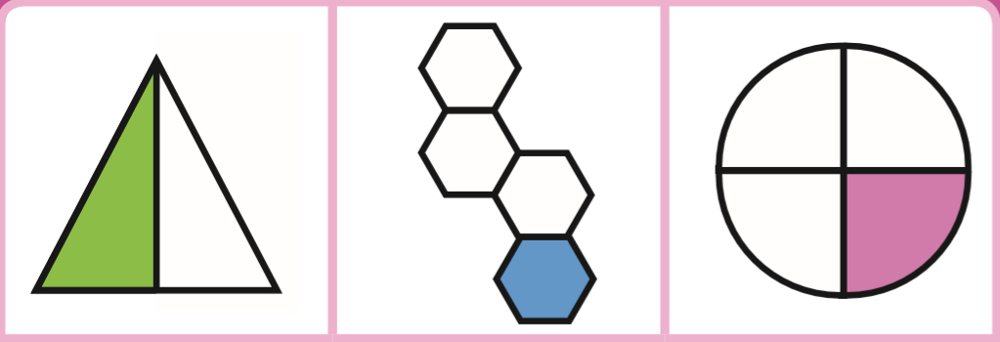

Now, try the activities to check your understanding:
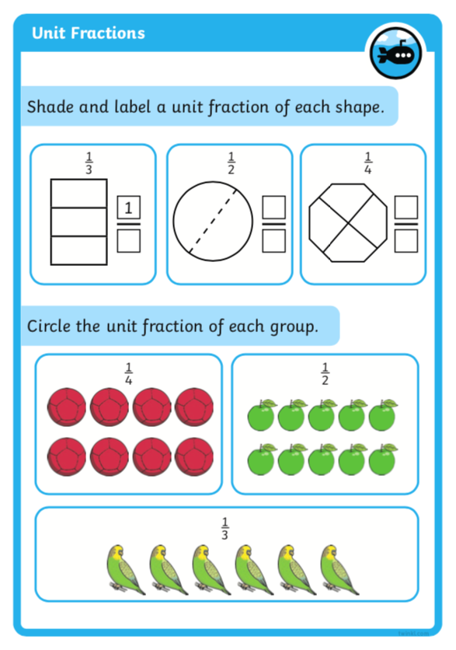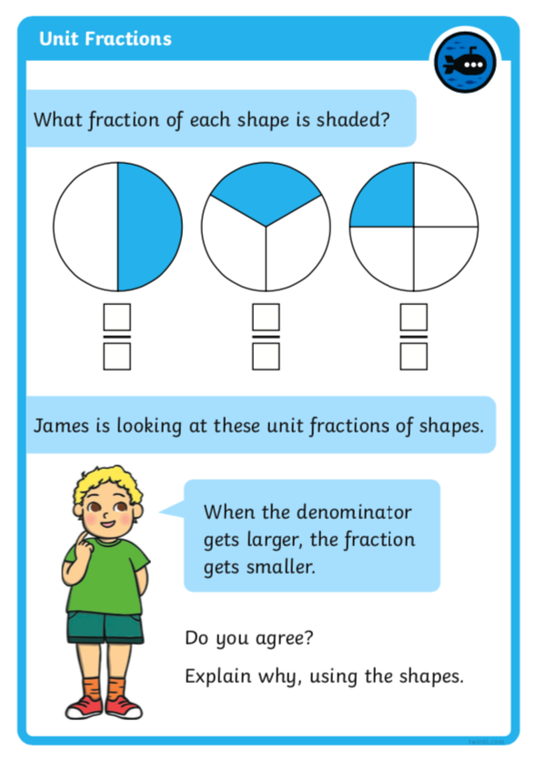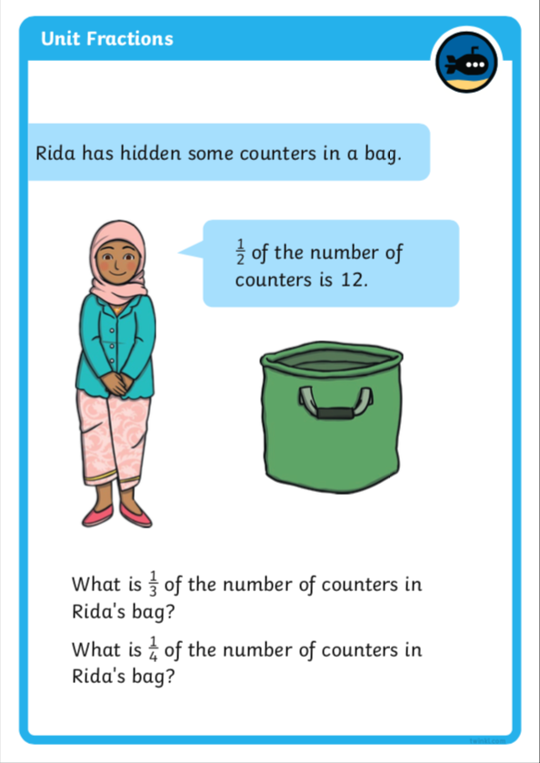

Challenges:

