Have you watched the lesson presentation about different states of matter?

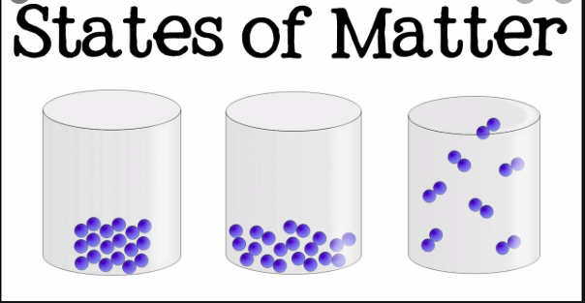

Once you have found out about the particles in solids, liquids and gases, create a poster to show the differences.

Here are some examples to help you:


