L.O. To be able to work out half of an even number up to 24 and a fifth of a multiple of 5 up to 60?

First, look at the Fractions PowerPoint presentation. Then choose from the activities below (they get more challenging as you go along). You can use objects to help you work out fractions - pasta, coins or any other small items are really helpful.

Activity 1

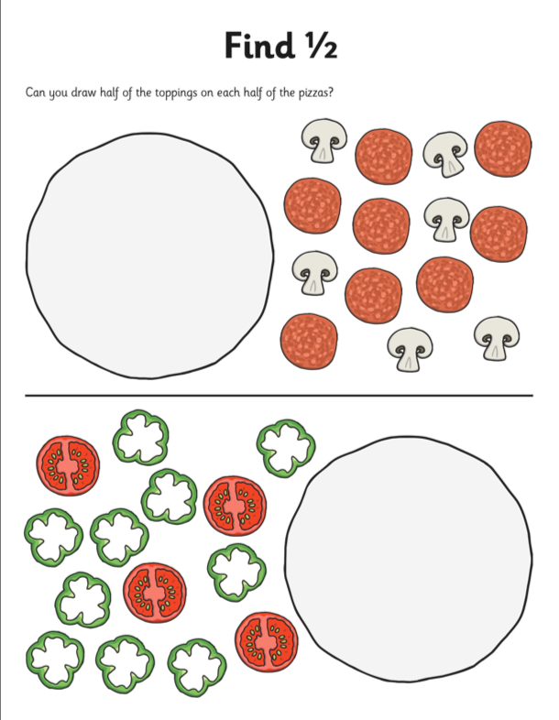
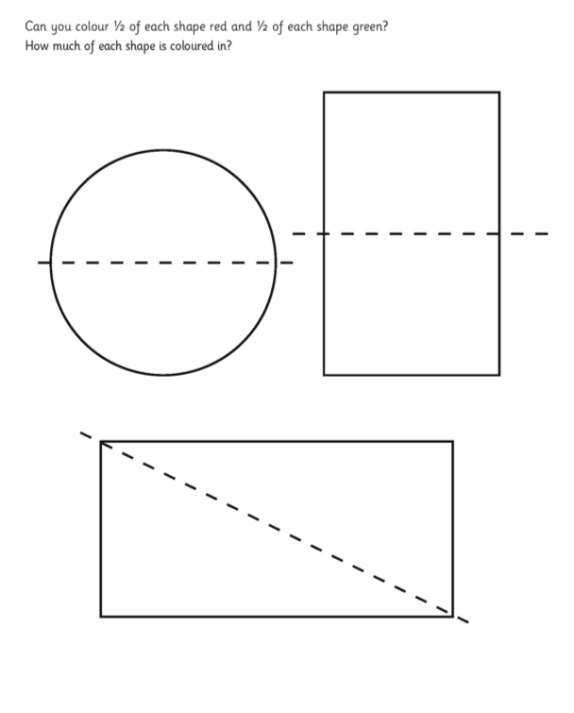

Activity 2

Find half of these even numbers. Draw out the problem or use small items to help.
E.g. half of 12 is = 6
I I I I I I | I I I I I I

Half of of 18 =

Half of 24 =

Half of 16 =

Half of 22 =

Half of 14 =

Half of 26 =

Half of 10 =

Activity 3
Finding one fifth of a number. Use your five times tables to find one fifth of the numbers.
e.g. One fifth of 20 = 4
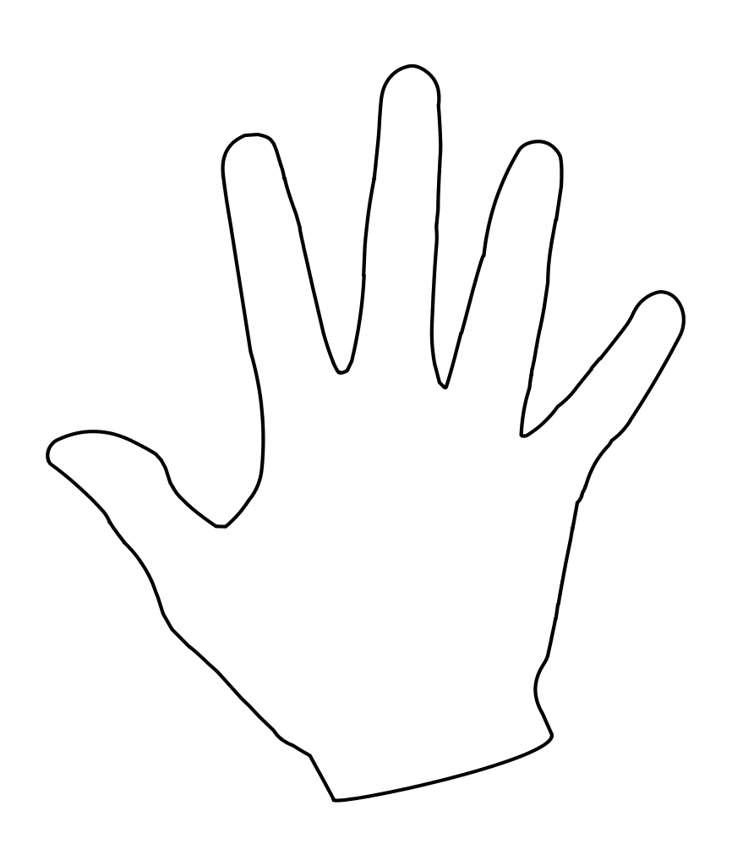
One fifth of 25 =

One fifth of 35 =

One fifth of 40 =

One fifth of 15 =

One fifth of 50 =

One fifth of 100 =

One fifth of 90 =

One fifth of 45 =

Challenges:

If one fifth of 20 is 4, what is one fifth of 200?

If one fifth of 10 is 2, what is one fifth of 1000?



