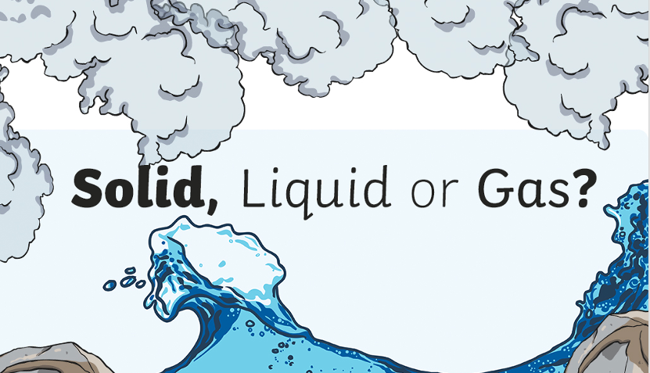

This week, we will learn a bit more about solids, liquids and gases.

To start, watch the video on BBC Bitesize:

https://www.bbc.co.uk/bitesize/topics/zkgg87h/articles/zsgwwxs
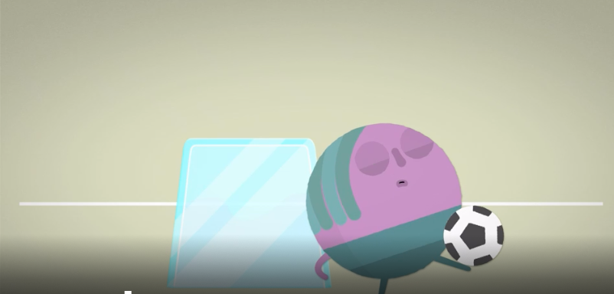
Now use the same link to play the game.

https://www.bbc.co.uk/bitesize/topics/zkgg87h/articles/zsgwwxs

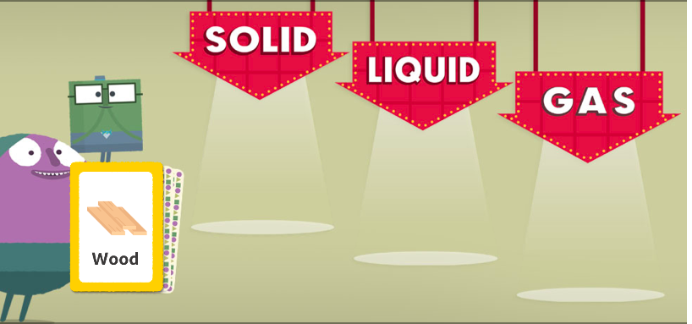

Now see if you can sort all the items below into the correct ‘state’. If you can, print them out and cut and stick them in the correct place on the table. Or you could make your own table and draw the items on!

Solids | Liquids | Gases


