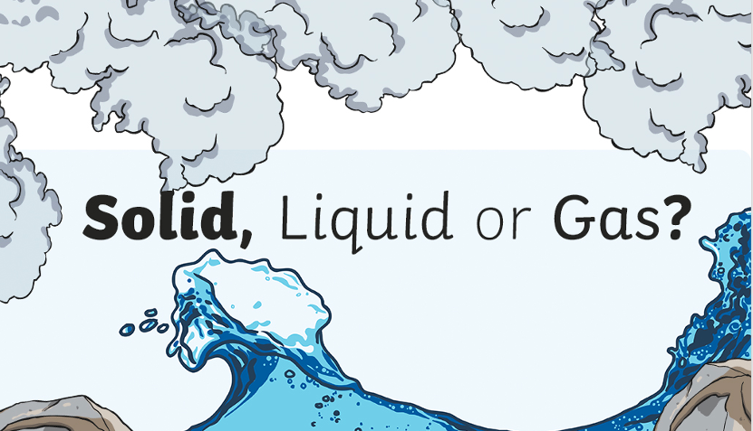

Our new topic for the Summer Term is ‘Solids, Liquids and Gases’. We will be learning about the difference between a solid, a liquid and a gas.

Let’s start by thinking about water.

Use the Powerpoint presentation to learn about water in the three different states.

Can you find any other examples of solids, liquids or gases around your home?

Record your findings on the table below or make a table of your own.

Solids | Liquids | Gases

