Home Learning - Spelling, Punctuation and Grammar
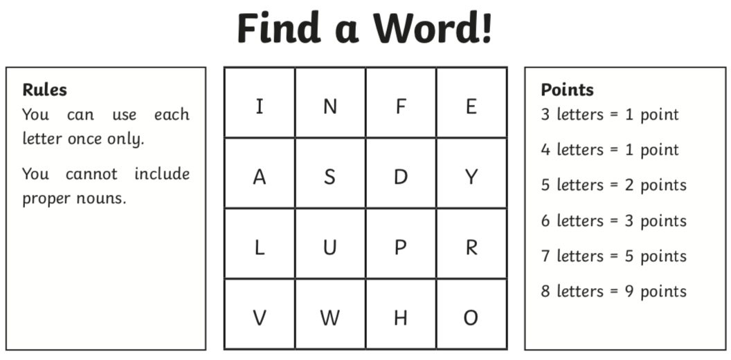
Write down as many words as you can spell using these letters:
TOTAL NUMBER OF WORDS:
TOTAL SCORE:

HELP! Find the words that match these pictures using the letters in the grid.
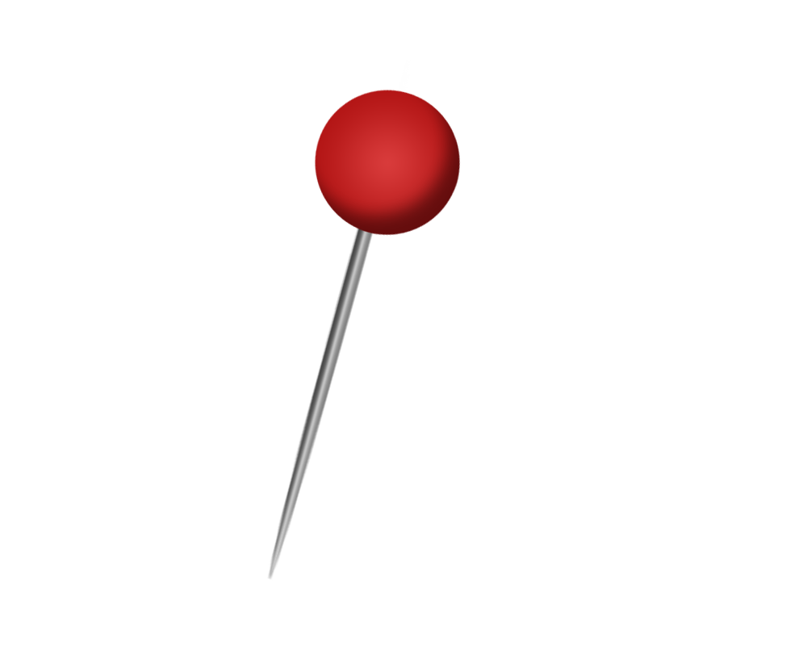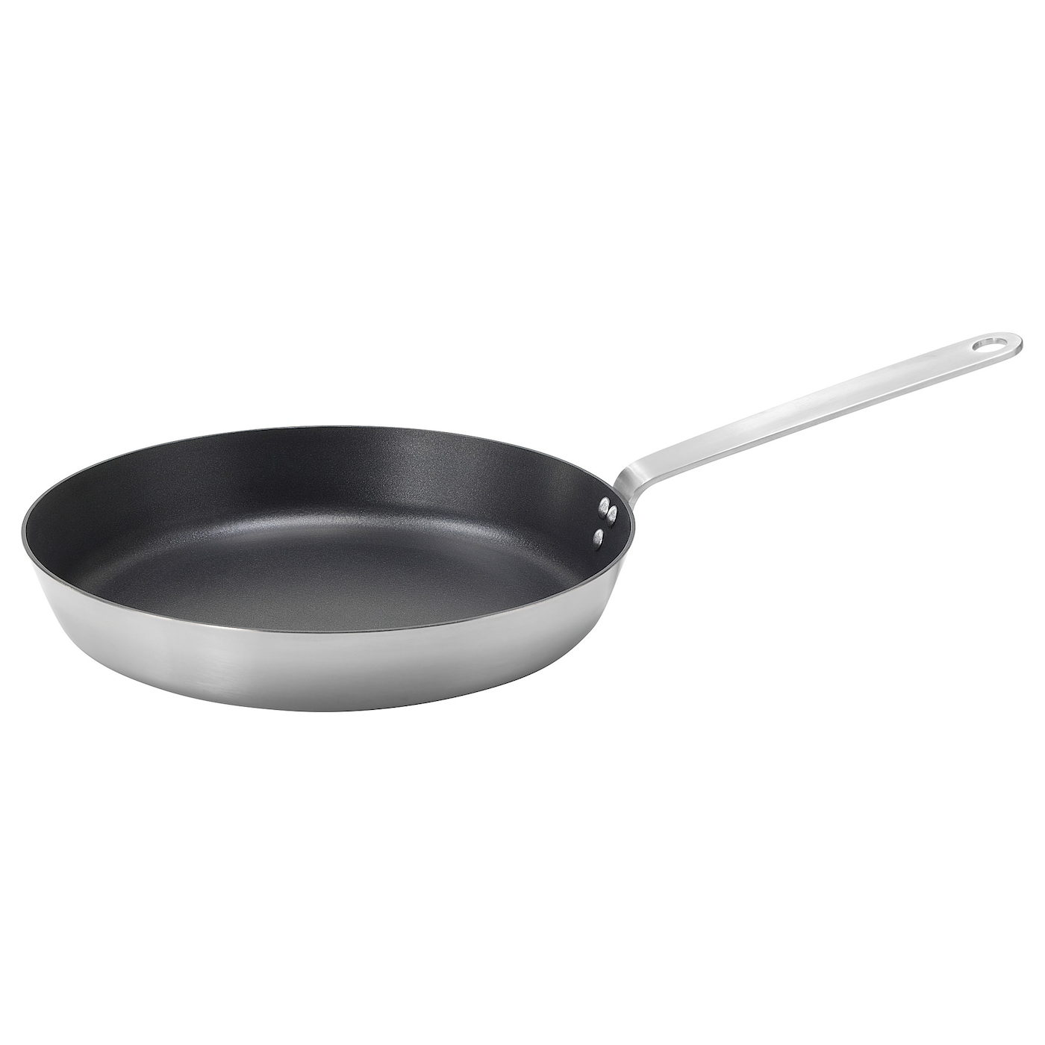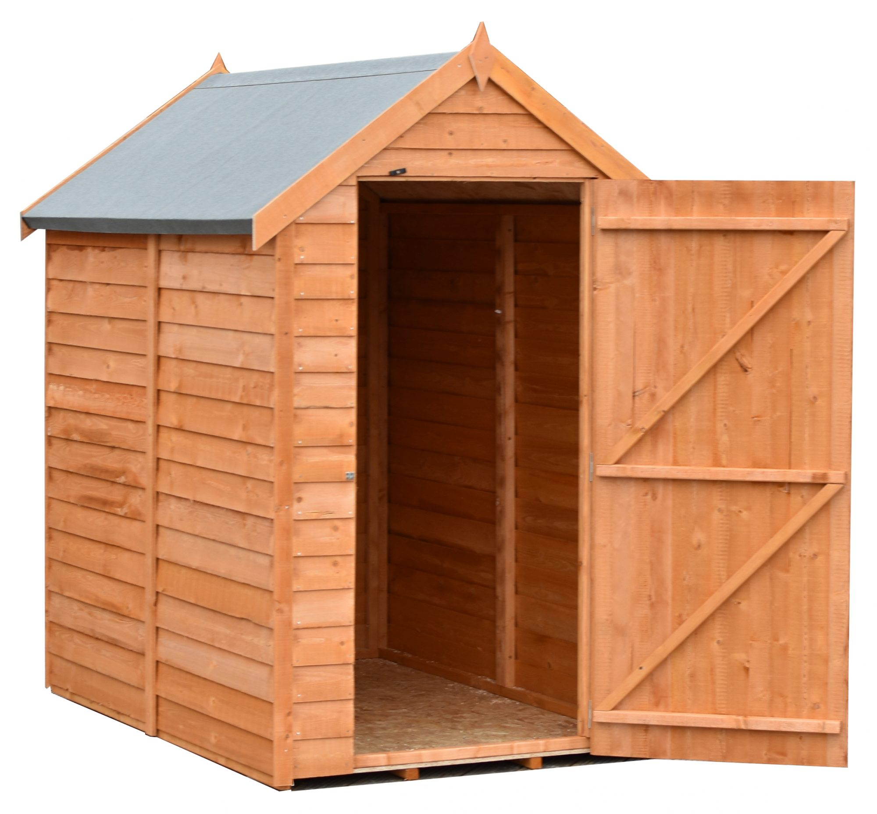
I NEED MORE OF A CHALLENGE…


