ASH CLASS – HOME LEARNING
Maths – Division Choose one of the tasks below:
Division using images:
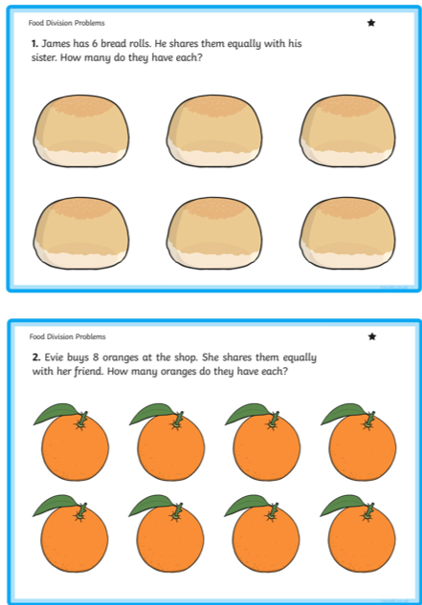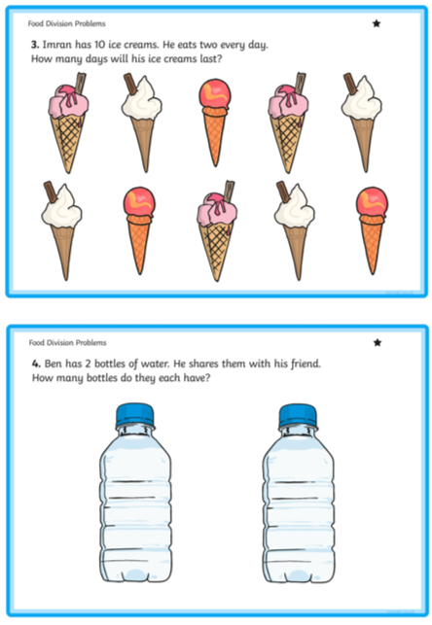

Short division no remainders:
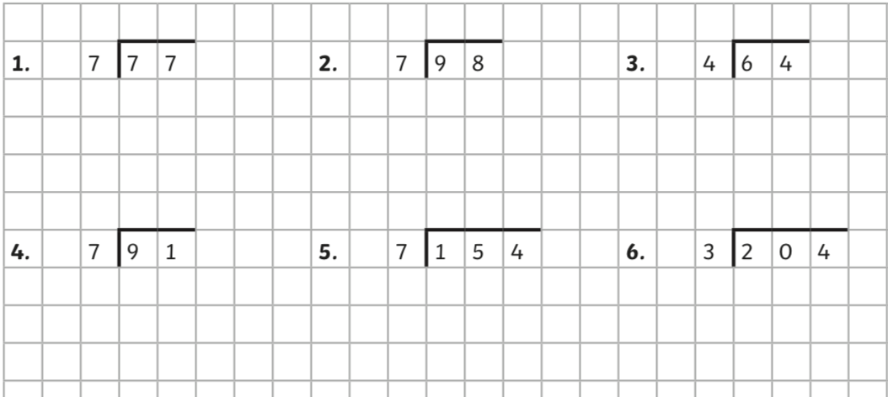

Short division with remainders:
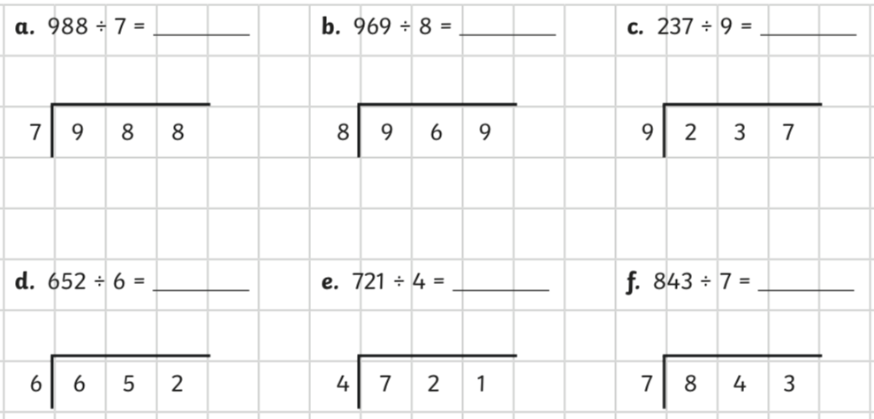

Challenge: Now can you come up with some of your own questions to answer?

English – Letter Writing
Read the letter below:
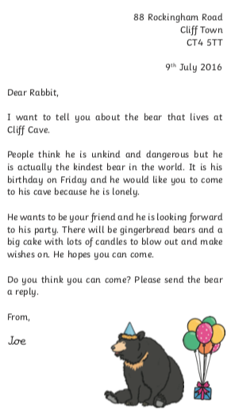
Write down examples of each of the features:

Date
Greeting
e.g. To ……
Sender’s address
Sender’s name

Write a reply to Joe’s letter including a made-up address, today’s date and a greeting.
Sign-off with your name.

