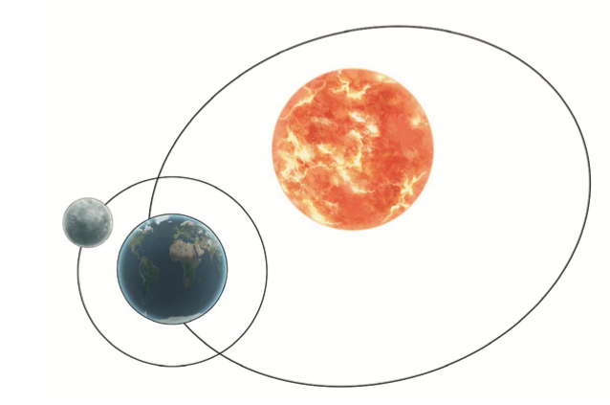

Optional challenge: Describe what is happening in the diagram using the key words below.

