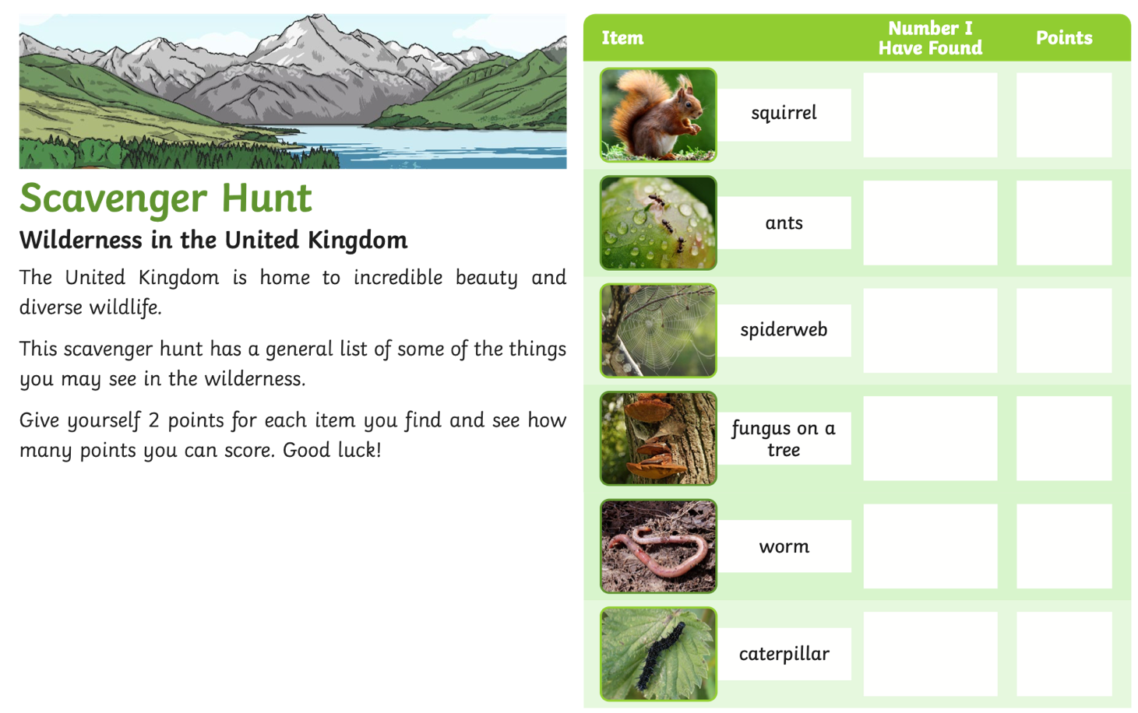
This week take a walk in your local area, this could be in a park, along a river path or around a lake. There is a list of various wildlife you can find in the UK. Give yourself 2 points for each item you find and see how many points you get.
When you find some of these think about where you find them!



