Science

Watch the videos linked below:

https://www.bbc.co.uk/bitesize/topics/zkgg87h/articles/zsgwwxs

https://www.bbc.co.uk/bitesize/topics/zkgg87h/articles/z9ck9qt

Then complete the crossword, there are clues to help you.


When you have finished write the definitions of the words in your own words, to help you remember their meaning!

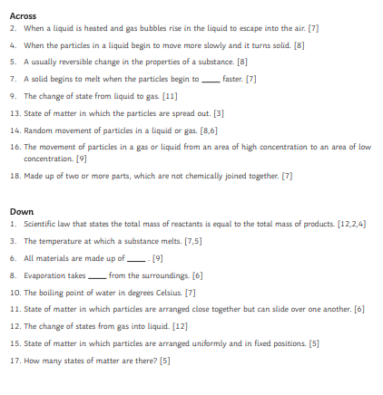

Word | Definition

