Spruce Maths – Bar charts and Data handling

Use the link below:

https://www.bbc.co.uk/bitesize/articles/zsrgp4j

You can work your way through the activities on the link, make sure you watch the video!

Once you have watched the video there are 3 activities to choose from below. Each page is labelled. You only need to complete 1 activity, but there is more than one page for each.

Activity 1 – I’m not too good with bar charts
Activity 2 – I’m okay with bar charts
Activity 3 – I’m great with bar charts, I can read and draw them!

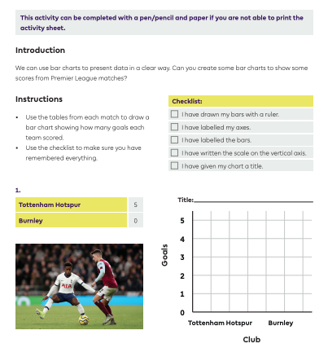
Activity 1 – Page 1

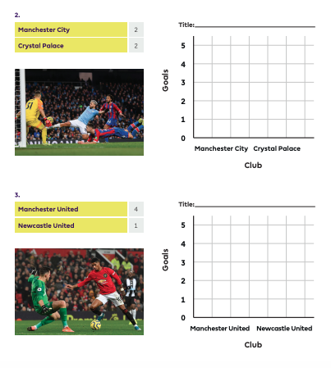
Activity 1 – Page 2

Activity 1 – Page 3
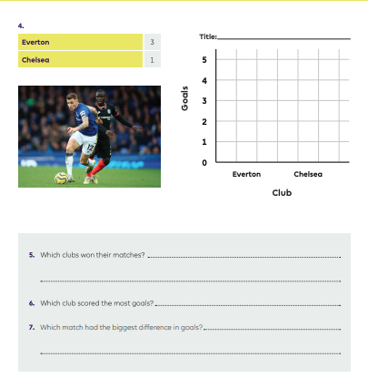

Activity 2 – Page 1
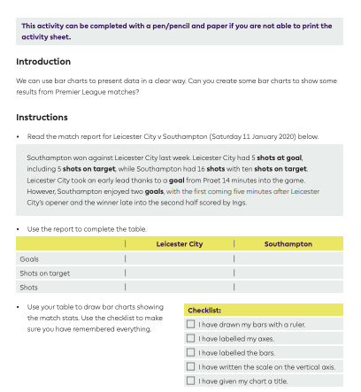

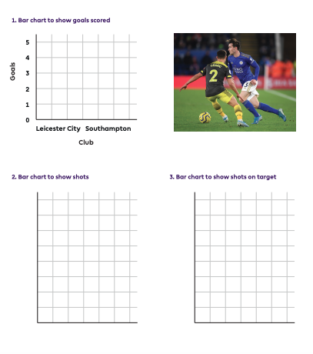
Activity 2 – Page 2

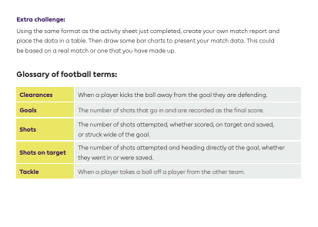
Activity 2 – Page 3

Activity 3 – Page 1

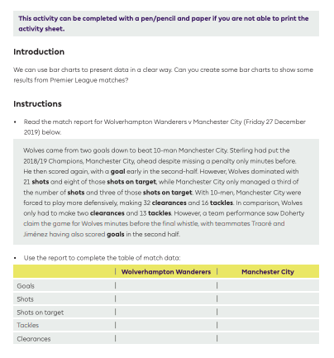

Activity 3 – Page 2

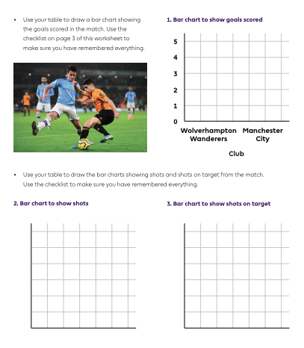

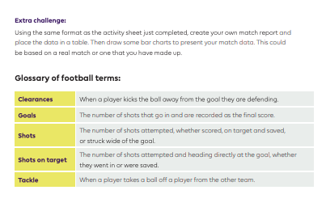
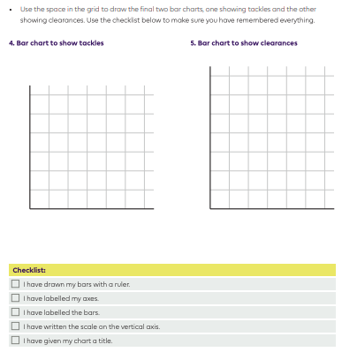
Activity 3 – Page 3

