Spruce English

This week your work is to plan a poem entry for a competition!

You need to use the Presentation PDF on the home learning page to help teach you about different poetic techniques.

Then complete the planning sheet, as next week you will be writing your poem!
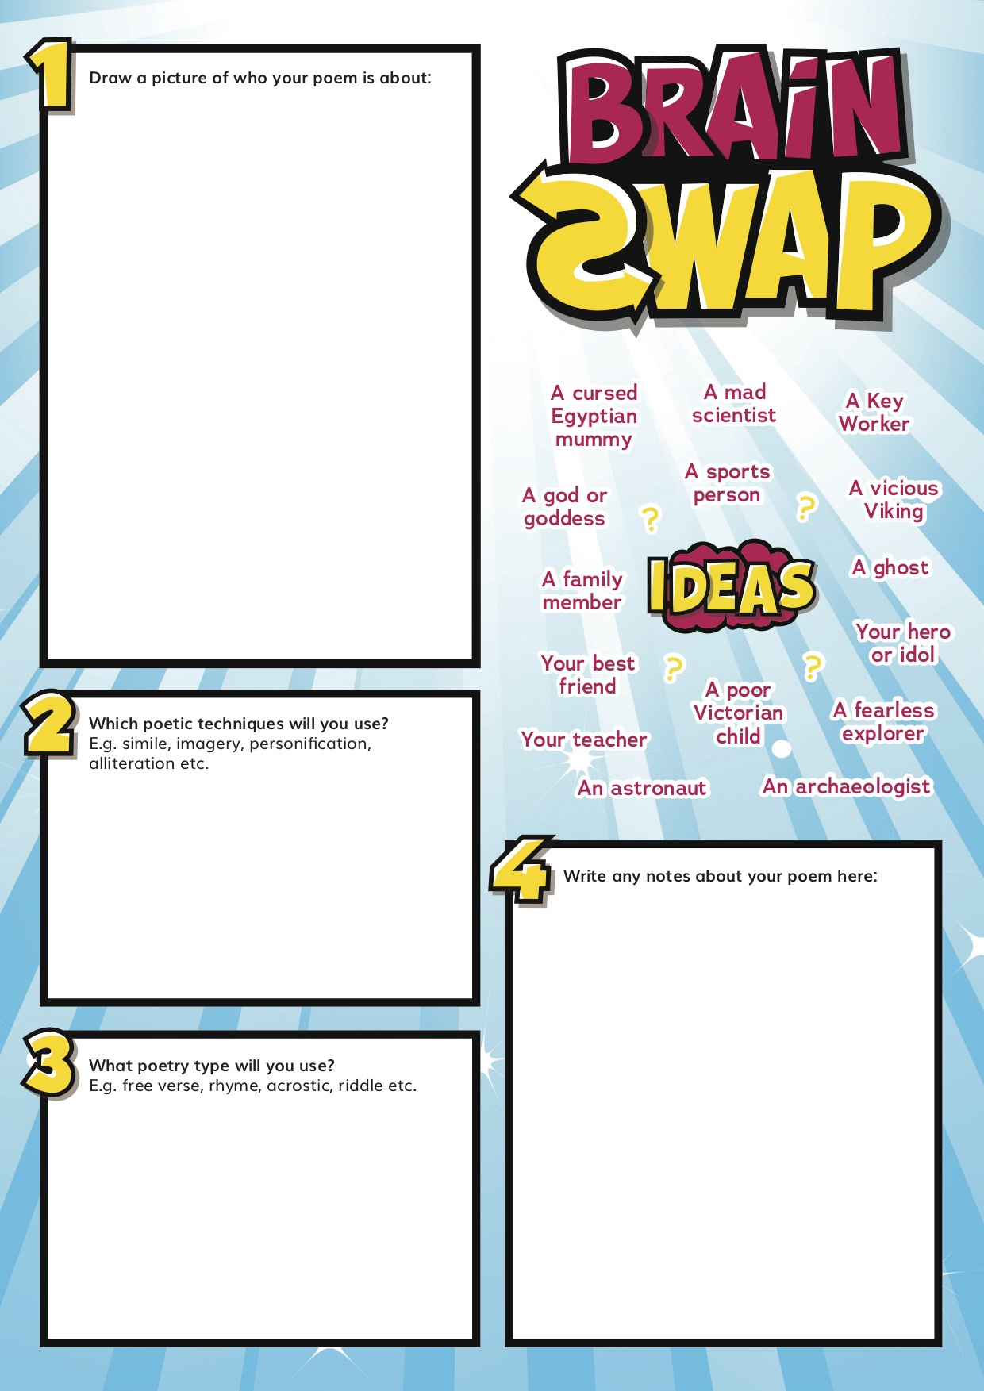
The planning sheet is below!

