This week for maths you will be completing multiplication and division problems.

If you need reminding, you can use the videos below.

https://www.bbc.co.uk/bitesize/topics/z36tyrd/articles/z2fkwxs

https://www.bbc.co.uk/bitesize/topics/z36tyrd/articles/zgxdfcw

Then complete 1 activity from below. They are labelled.

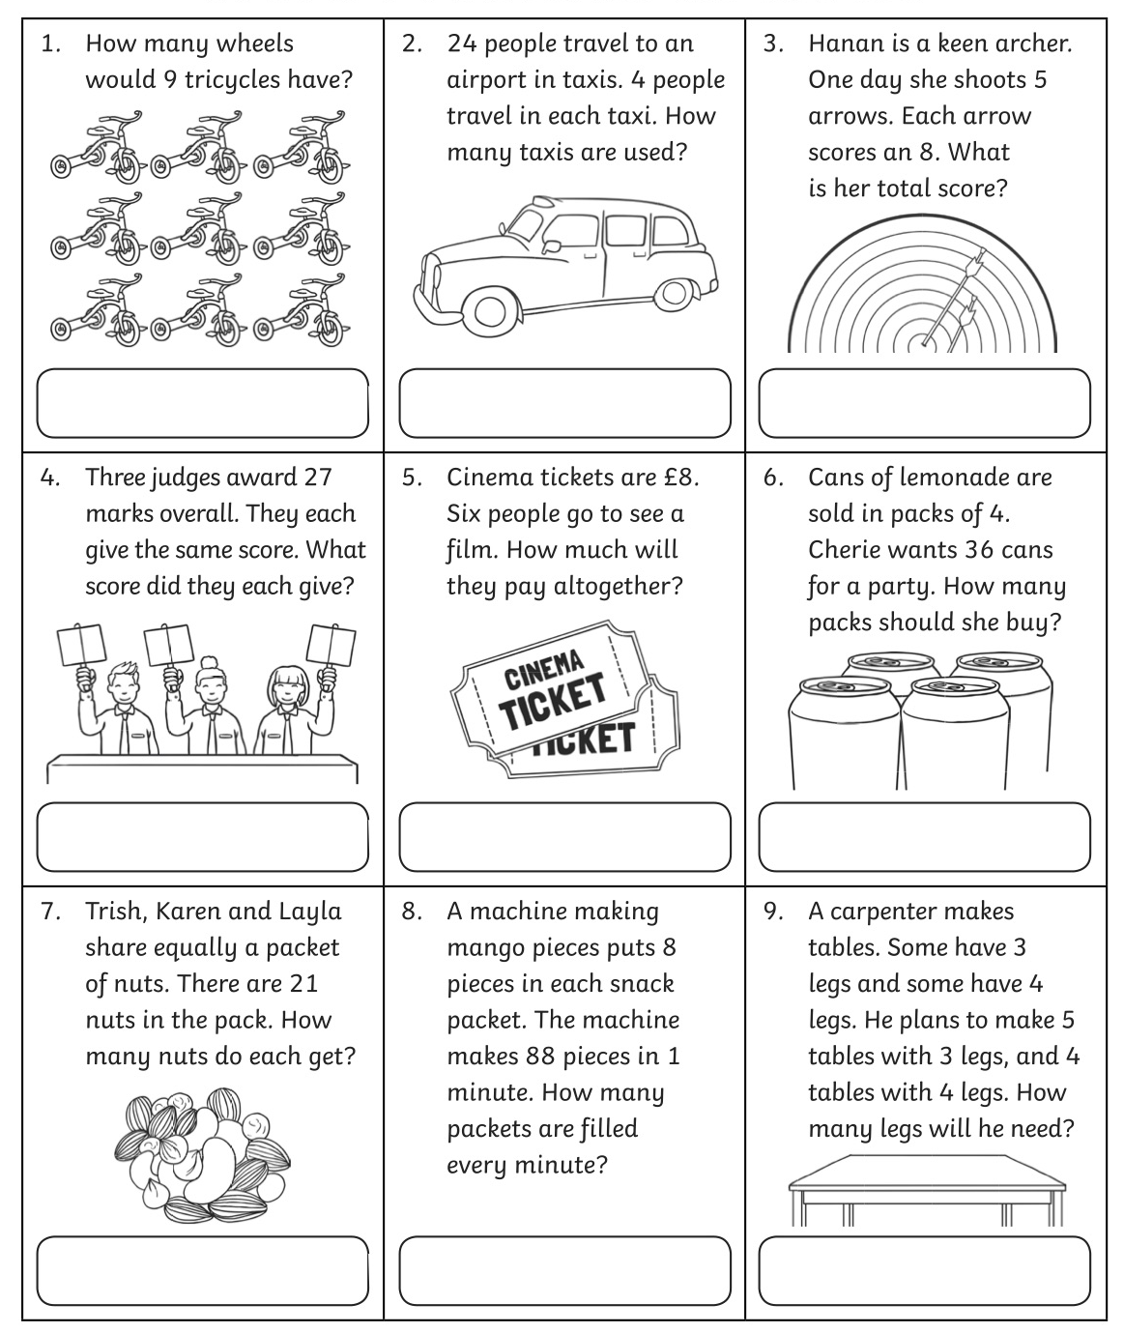
Activity1 – I’m not very confident at multiplication and division

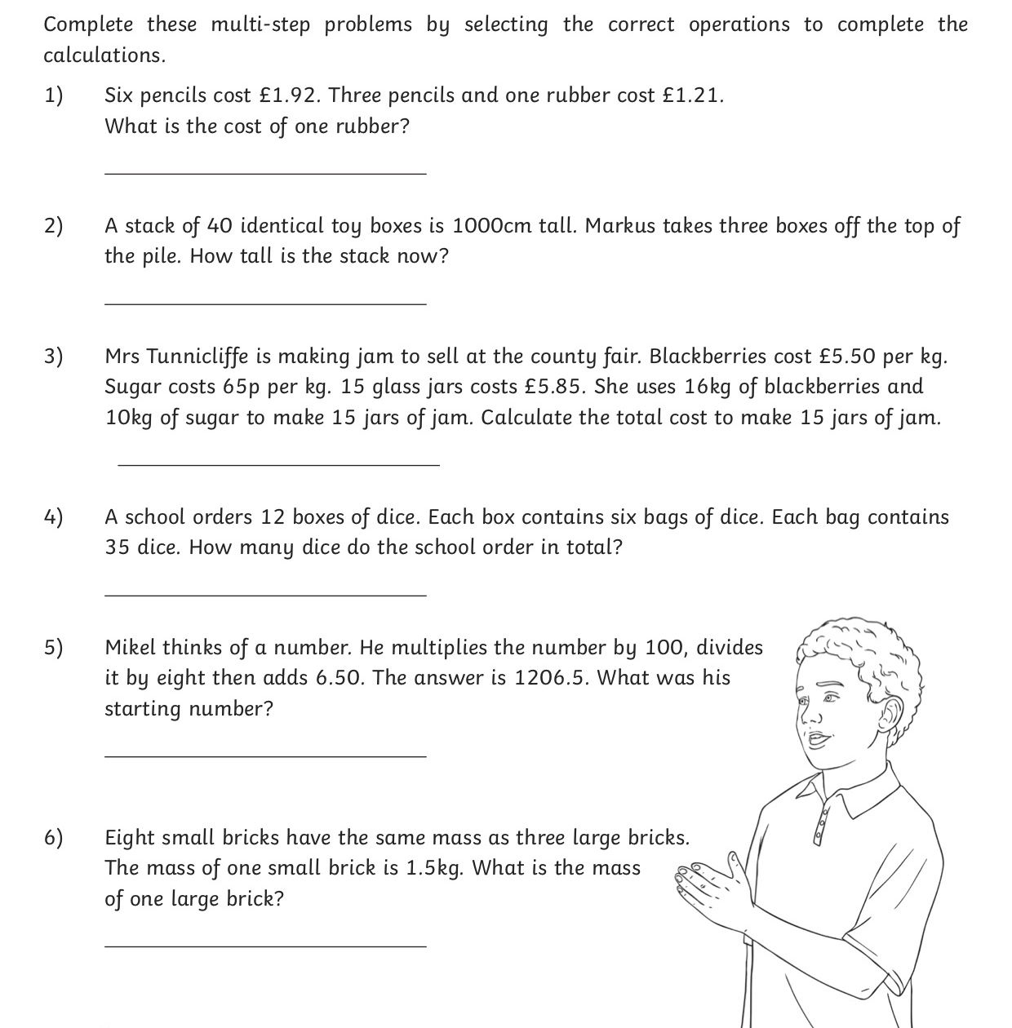
Activity 2 – I’m okay with multiplication and division

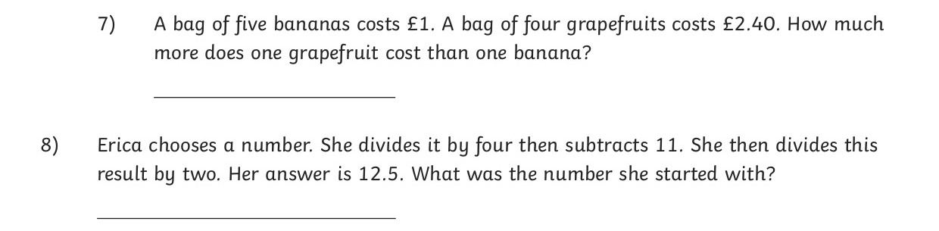

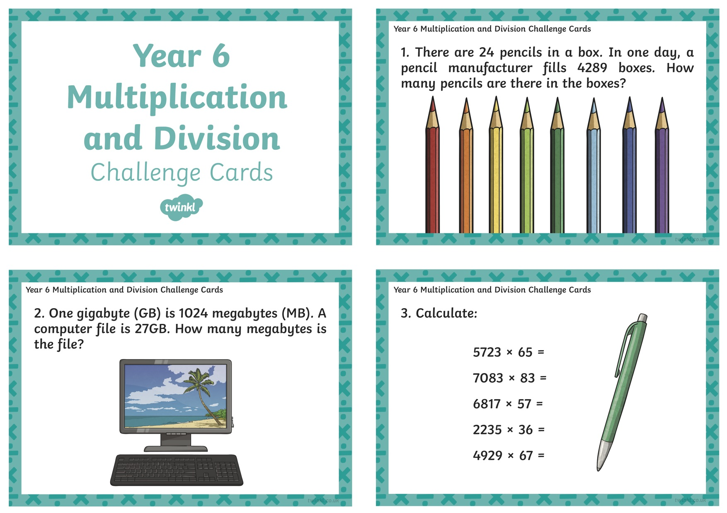
Activity 3 Page 1 – I’m really confident at answering multiplication and division questions.

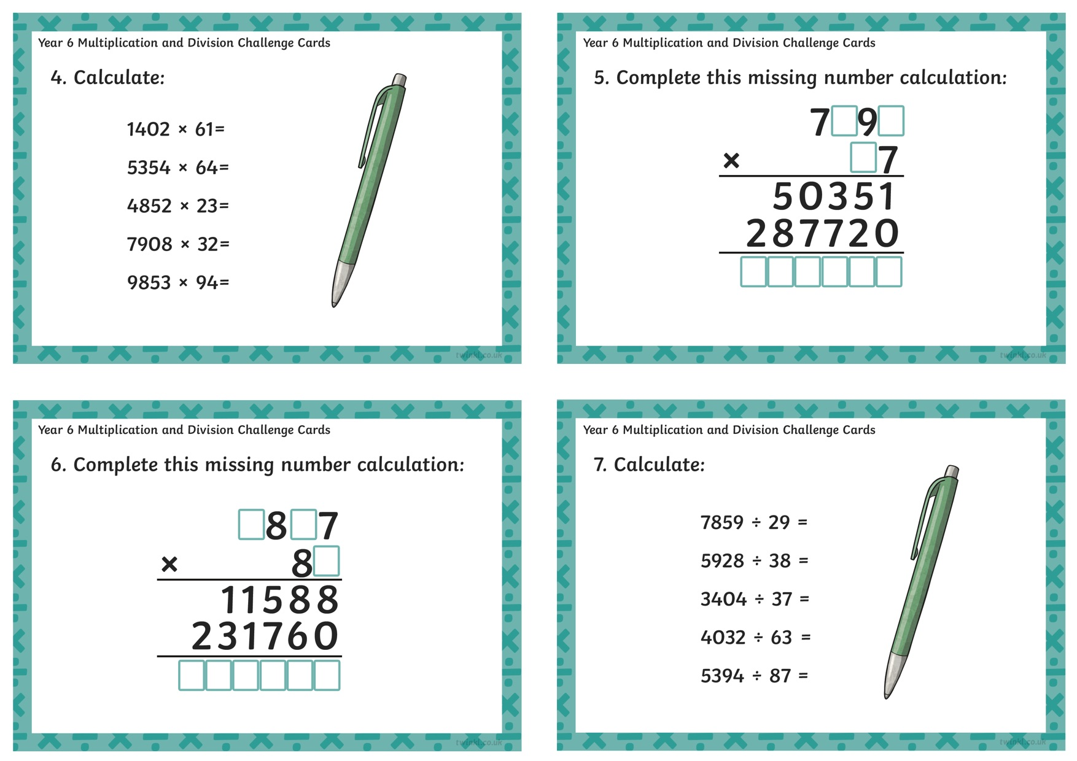
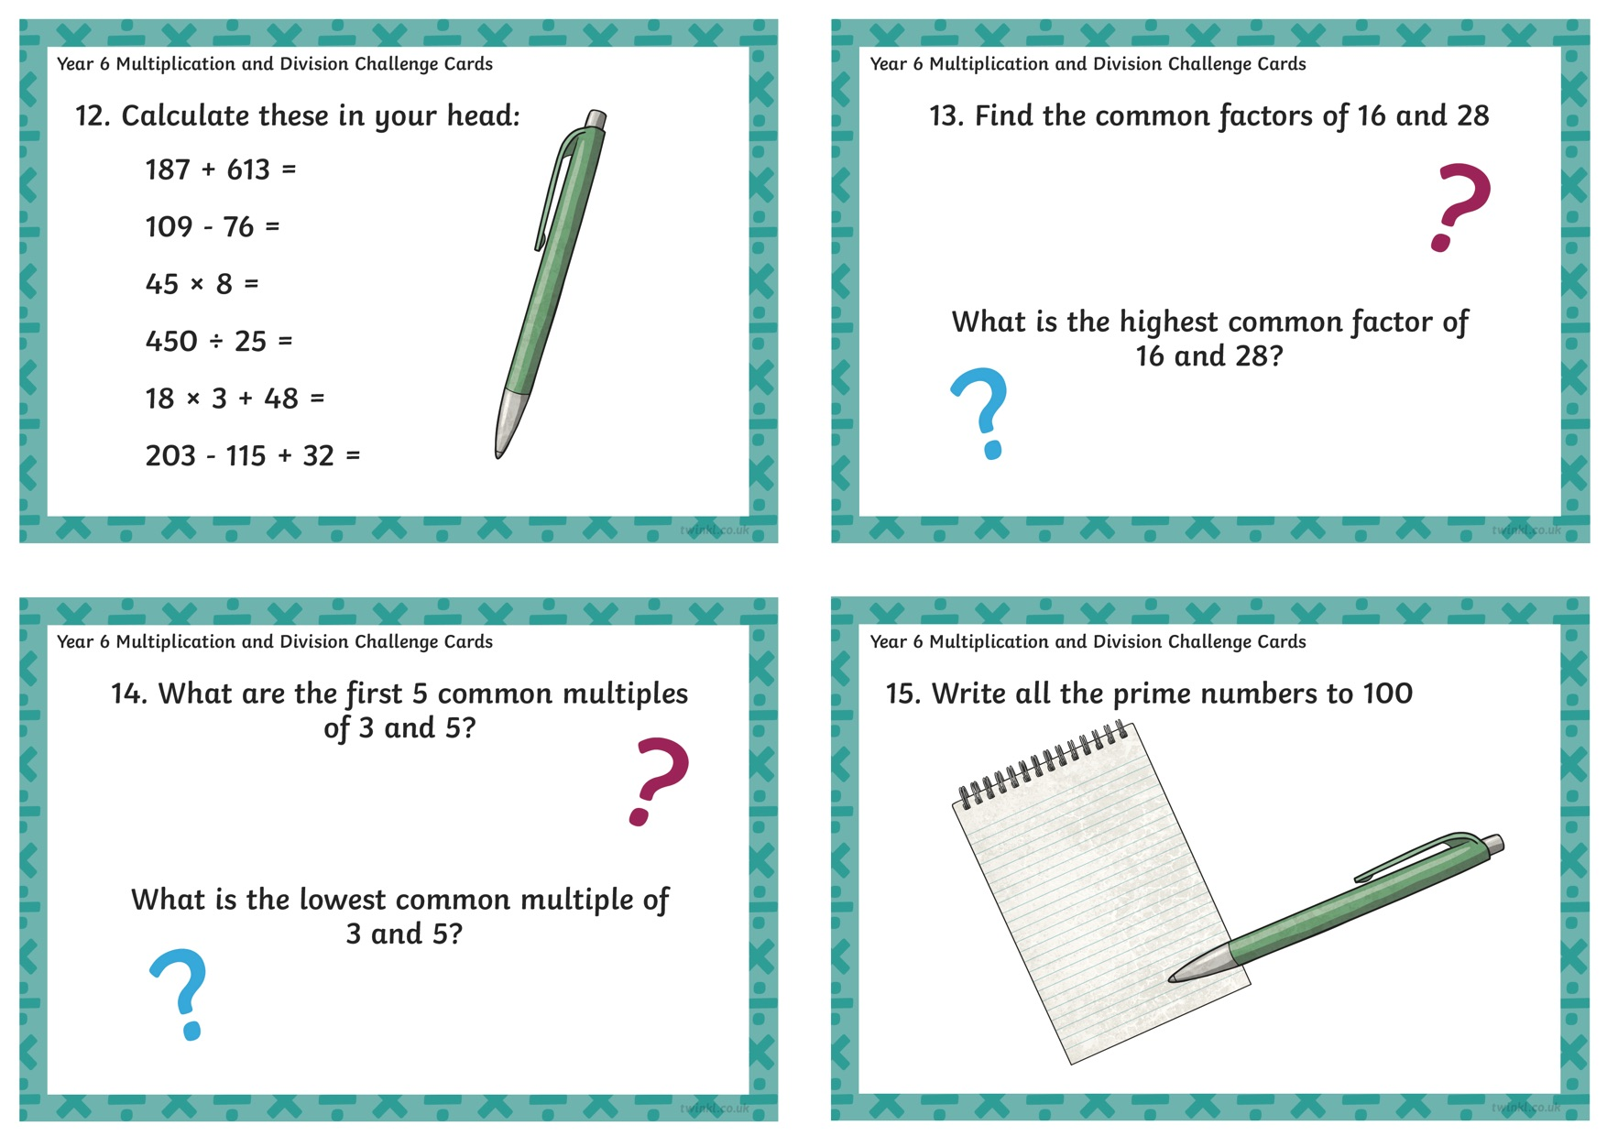
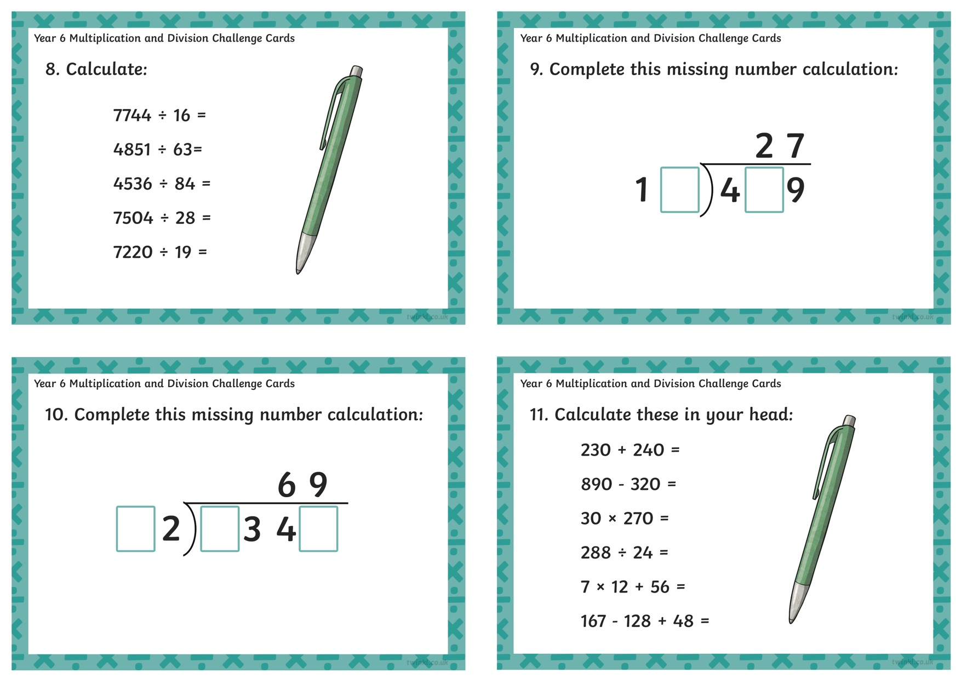
Activity 3 Page 2

