PSHE
Team work
Complete the lesson on BBC Bite size linked below. There are lots of clips to watch and thinking to do. This week is all about team work. https://www.bbc.co.uk/bitesize/articles/zdq3bdm

Once you have watched all the videos on the website, complete the worksheet below.
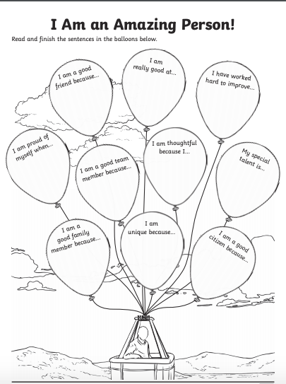
In this activity think about what your strengths are and how you could apply that to working as a team.Finishing the sentence starters in the balloons will help you visualise the talents you have and how others would value them.

