Spruce Maths
Addition and Subtraction
Problem Solving

Instructions
Watch the video below if you need a reminder on how to complete problem solving questions.

https://www.bbc.co.uk/bitesize/topics/z69k7ty/articles/zpwwy4j

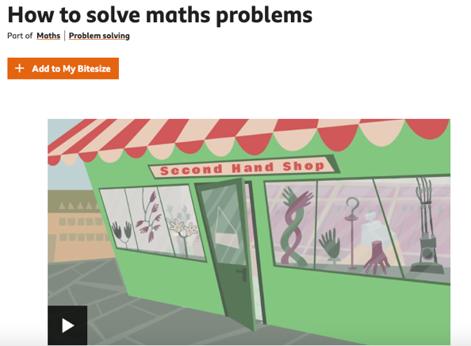

Then complete 1 activity – they are labelled at the top of each page.
Activity 1 – I find addition and subtraction and problem solving hard.
Activity 2 – I’m okay with problem solving
Activity 3 – I’m confident with addition and subtraction and I like problem solving.

Activity 1 – Page 1
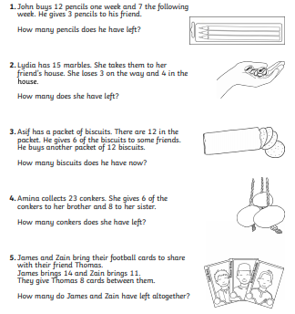

Activity 1 - Page 2

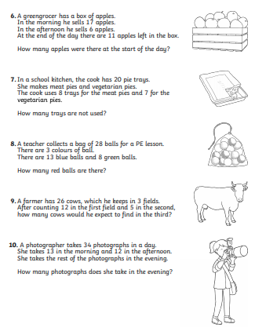

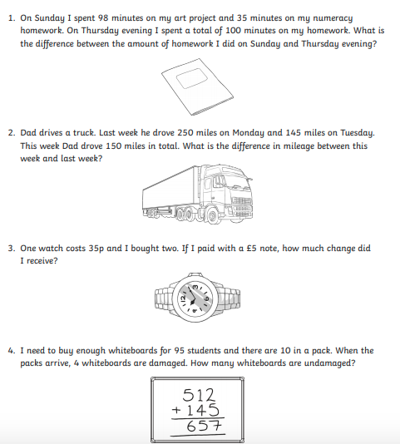
Activity 2 - Page 1

Activity 2 – Page 2

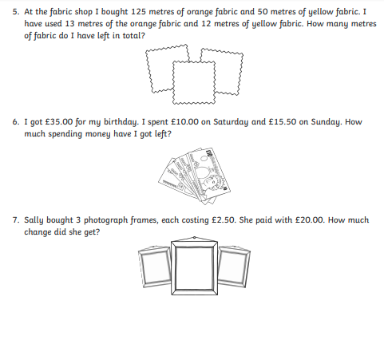

Activity 3 – Page 1
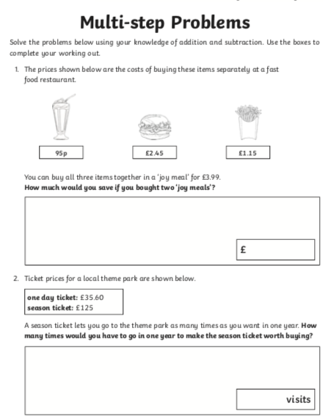

Activity 3 – Page 2

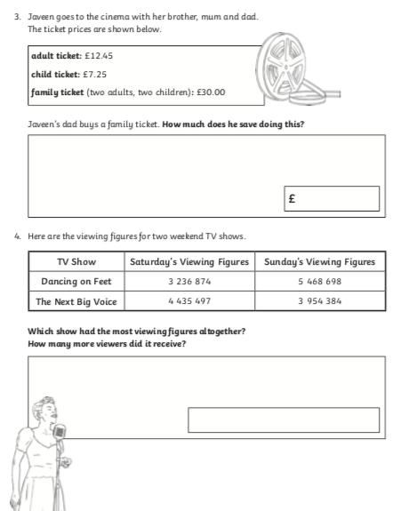

Activity 3 – Page 3


