Spruce English – Instruction Writing

Last week you learnt how to use imperative verbs, this will help you this week!

This week you are going to write instructions or a recipe!

Instructions
To learn how to do write instructions/ a recipe watch the video below:

https://www.bbc.co.uk/teach/class-clips-video/english-ks1-ks2-how-to-write-instructions/zrvtscw

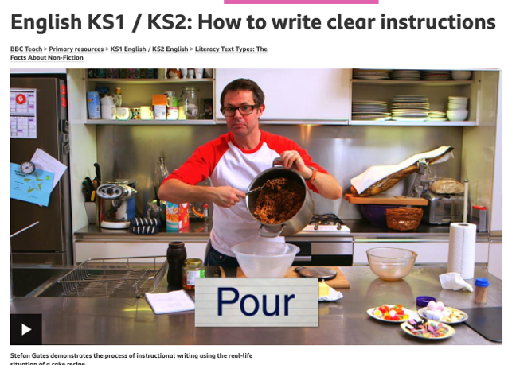

Then complete 1 activity below. They are labelled. You can use the poster below to help you.

Activity 1 – I’m not great with instruction writing
Activity 2 – I’m okay with instructions
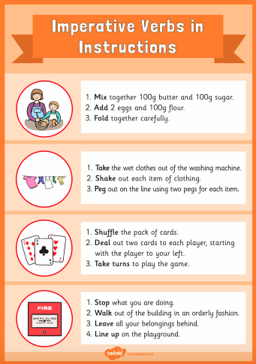
Activity 3 – I’m great at writing instructions

Activity 1 – Page 1

Your activity is to write how to make a jam sandwich. Use the instruction example to help you then complete the activity.

Example:
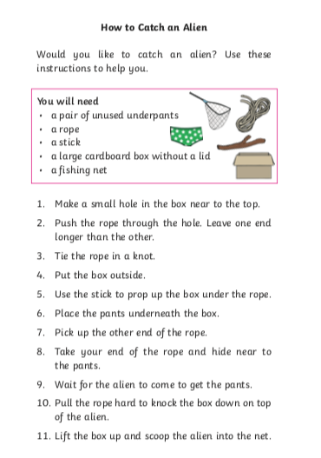

Activity 1 – Page 1

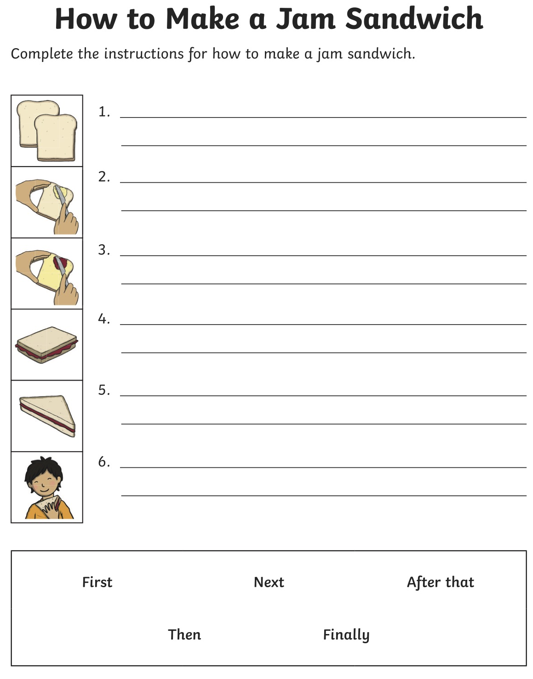

Activity 2 – Page 1

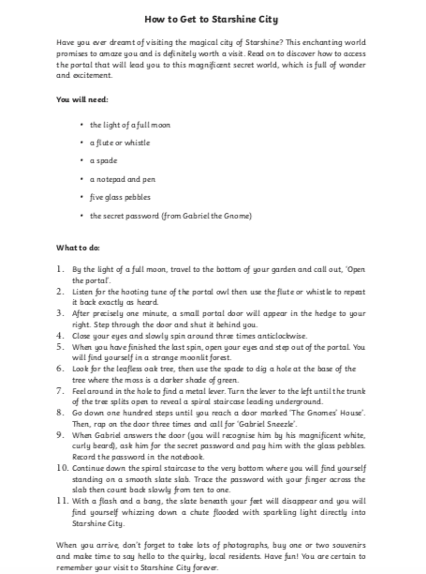
Use the example text to help you. You are writing instructions on making a magic potion or who to get to a secret location. This could be a magical place or somewhere secret. There is a template for you instructions on the next page.

Activity 2 – Page 2
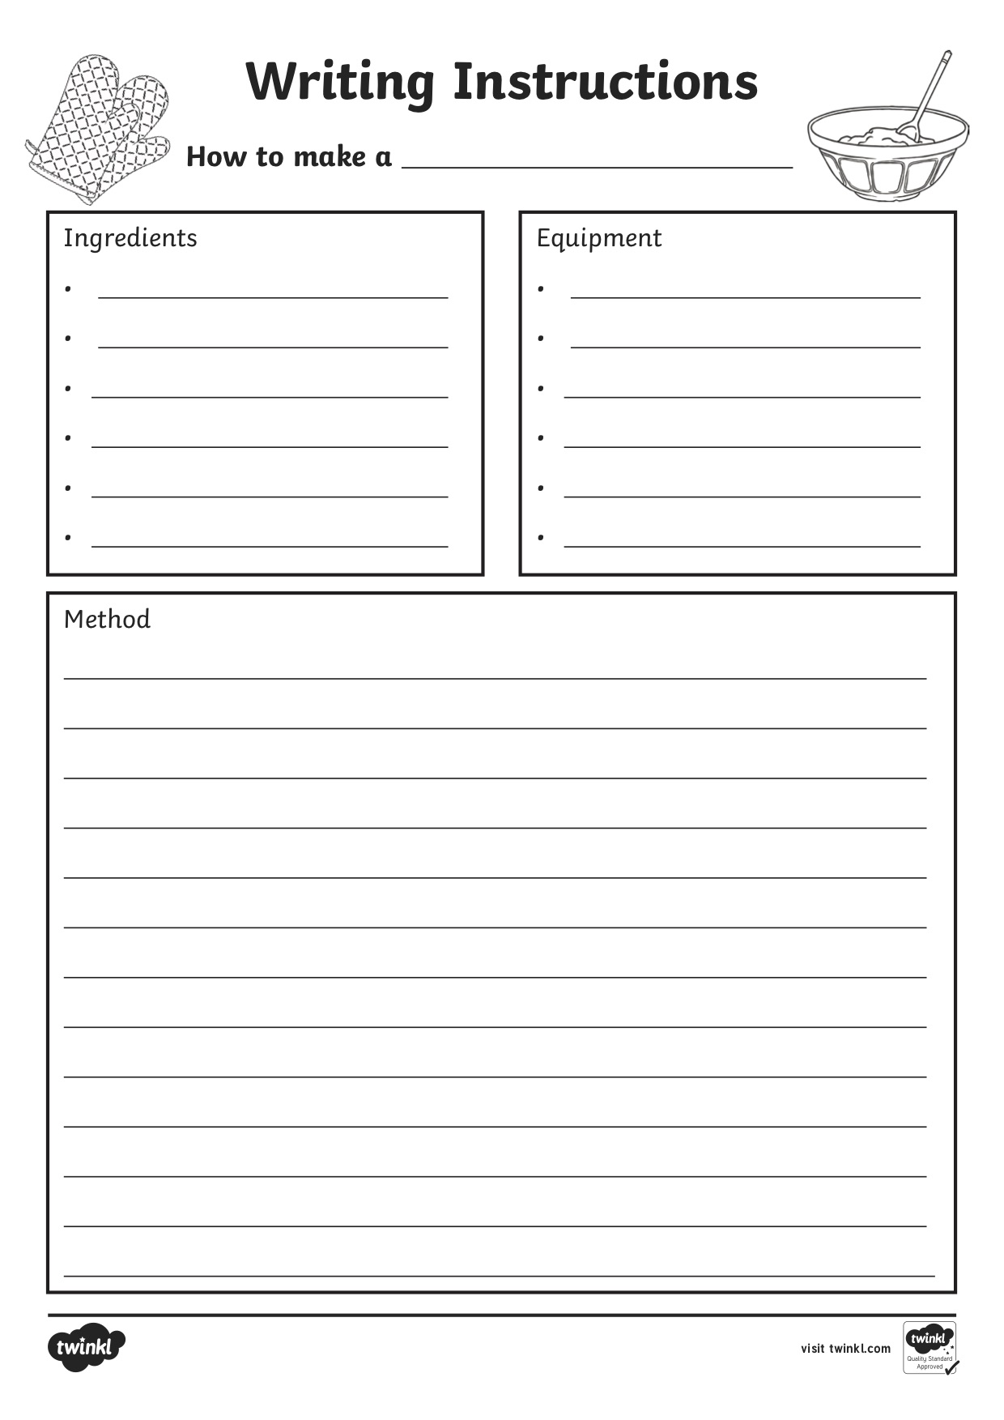

Activity 3 0 Page 1

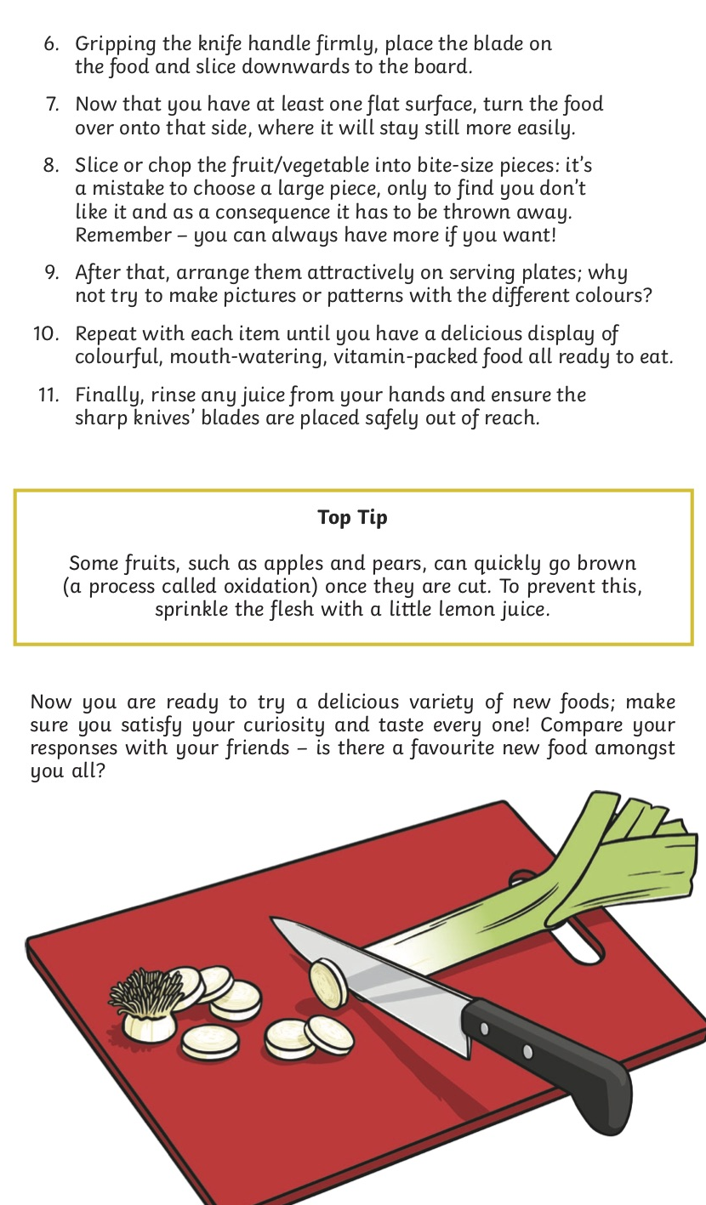
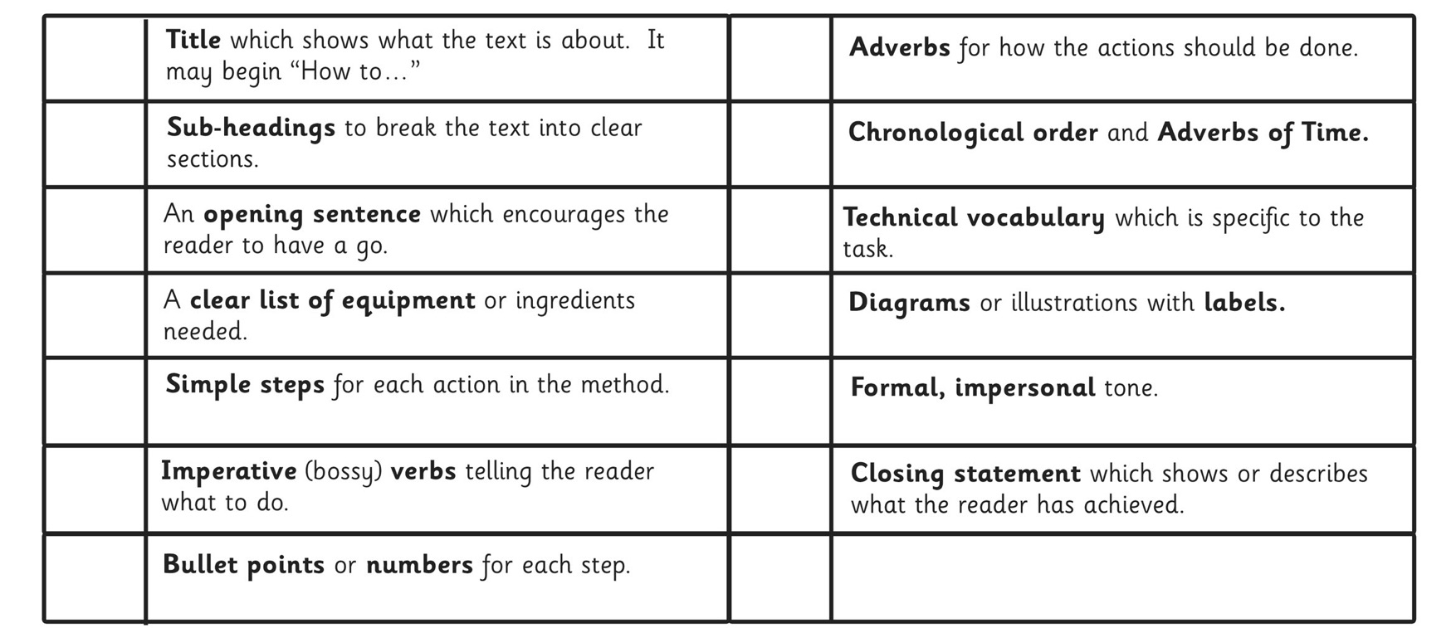
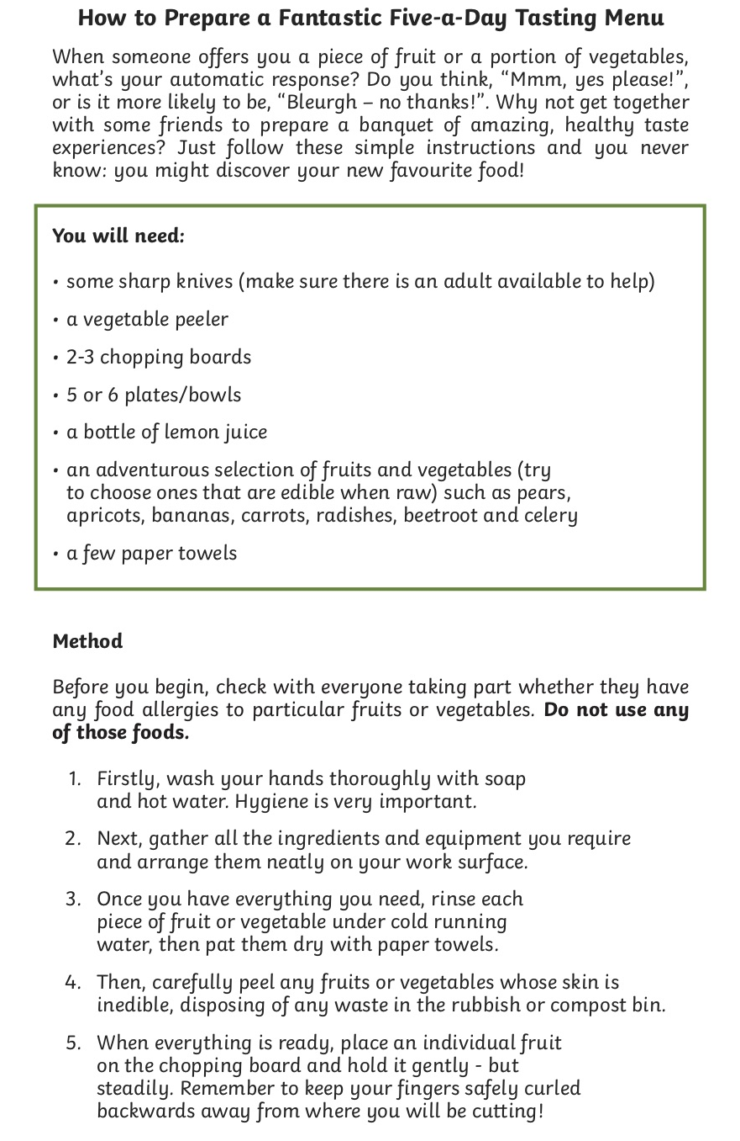
You can choose what you would like to write your instructions/recipe for. Use the checklist below to help you write it and the example text to give you a guide.

Activity 3 Page 2

