Science – Tim Peak

Complete this online activity learning about space and Tim Peak.

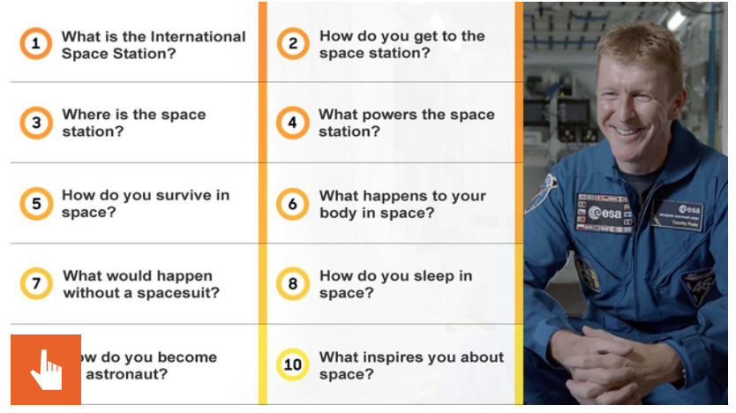
https://www.bbc.co.uk/bitesize/topics/zw44jxs/articles/z822hv4

Then complete a fact file below about what you have learnt. It can be about any area, Tim Peak, Space Stations, Rockets, Space, you choose!



