Learning Quest – Martin Luther King Jr.

Watch the video below about Martin Luther King Jr.

https://www.bbc.co.uk/bitesize/topics/zjkj382/articles/zknmrj6

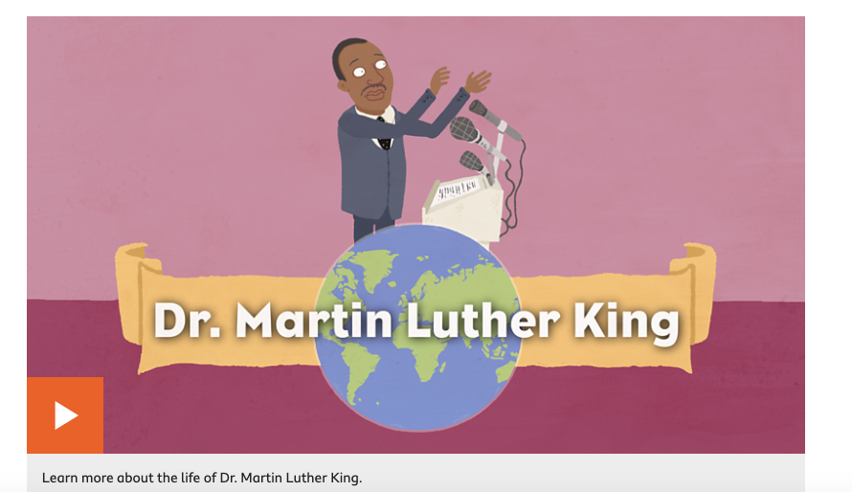

https://www.bbc.co.uk/programmes/articles/4mYSfdJBpkY6rCDMrGwgS0y/dr-martin-luther-king-dream-on



