Spruce Maths

Time.

Watch the videos linked below and then complete 1 activity.

Analogue clocks
https://www.bbc.co.uk/bitesize/topics/zhk82hv/articles/zcmdwxs
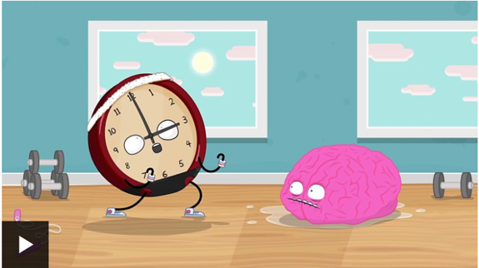

Digital and 24 hour clocks
https://www.bbc.co.uk/bitesize/topics/zkfycdm/articles/zcrmqty
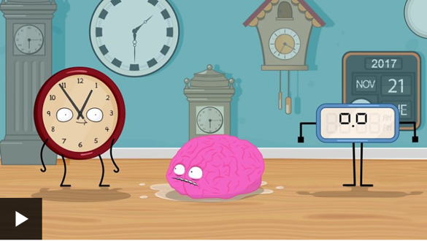

Activity 1
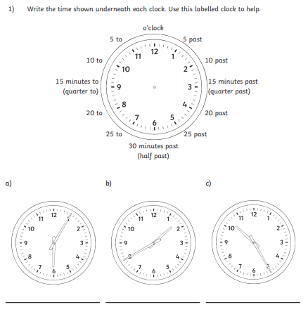

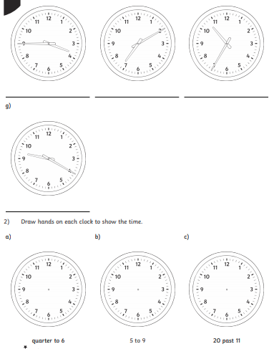

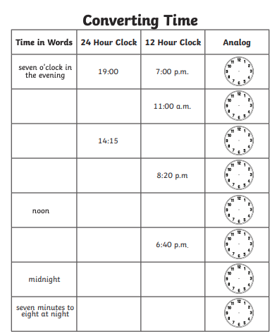
Activity 2

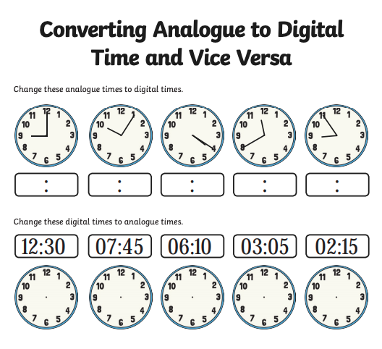
Activity 3



