Spruce English

Nouns and Verbs

You can watch the videos linked below to recap nouns and verbs.

Nouns https://www.bbc.co.uk/bitesize/articles/zjrdwty
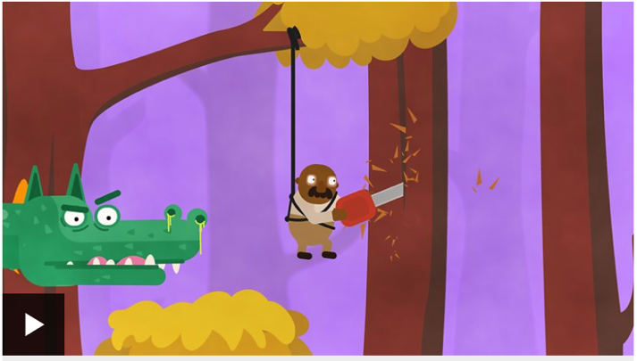

Verbs https://www.bbc.co.uk/bitesize/topics/zwwp8mn/articles/zpxhdxs
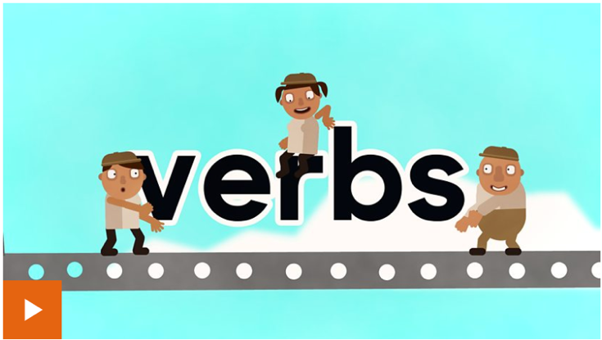

There are 3 activities to choose from below.

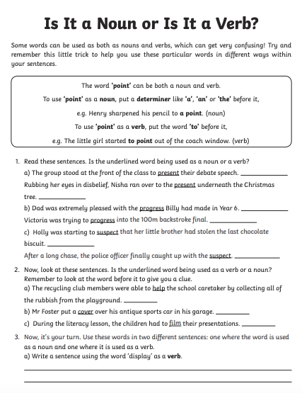
Activity 1

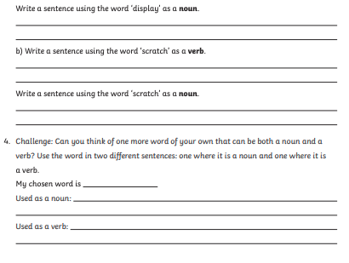

Activity 2
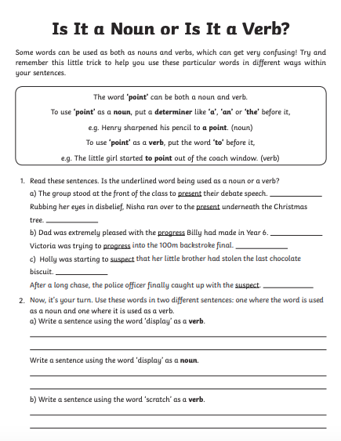

Activity 3



