Spruce English
Use the Powerpoint on the website to help you understand different determiners.

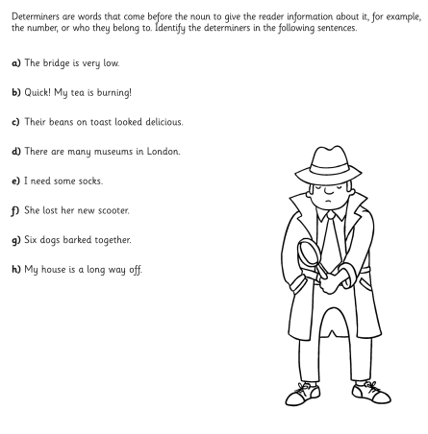
Then complete one activity from below.

Activity 1

Activity 2

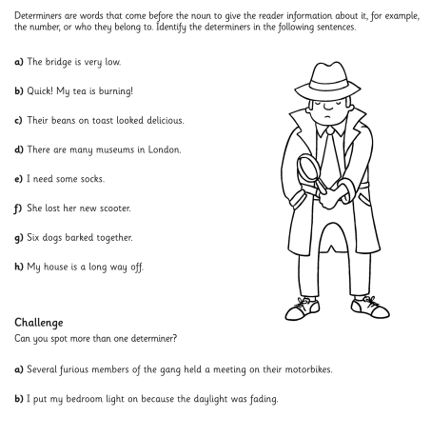

Activity 3


