This week’s work focuses on Translating Shapes.
As usual choose one activity. Each is a little bit harder. There is also a challenge at the bottom!

Translating Shapes

Translation is when a shape is moved a certain distance from its original position.

To explain this a bit better you can watch this video: https://www.bbc.co.uk/bitesize/topics/z2dqrwx/articles/zcjs97h

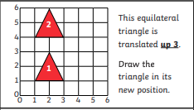
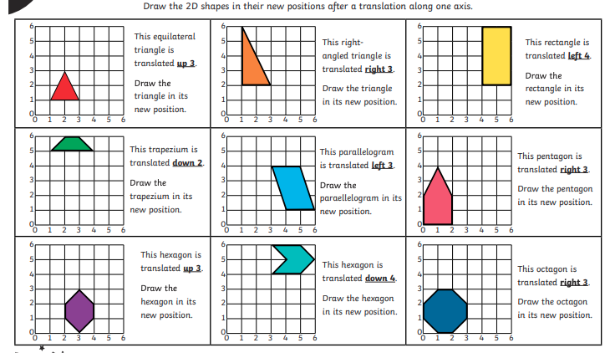
Activity 1 - The first one has been done for you.

Activity 2
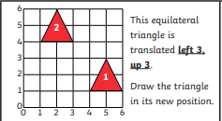
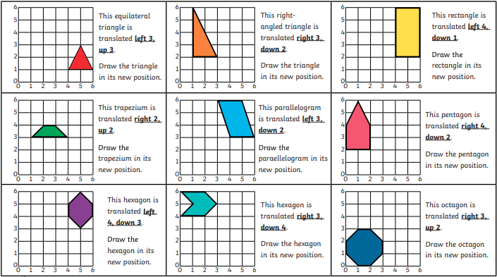
The first one has been done for you.
Activity 3
The first one has been done for you.
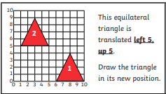
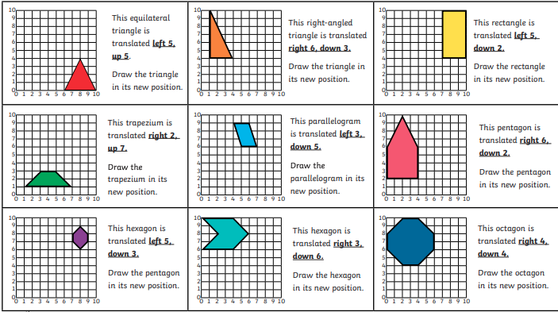

Challenge

Watch this video to help you complete the challenge.
https://www.bbc.co.uk/bitesize/topics/zgthvcw/articles/z96k9qt


