Science

Watch this video:
https://www.bbc.co.uk/bitesize/topics/zkgg87h/articles/zydxmnb

Underneath the video is an activity, complete this.

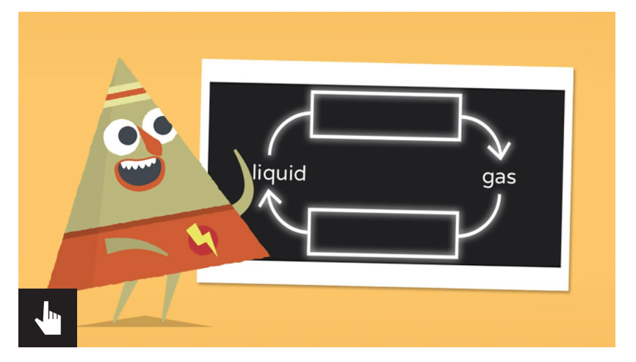

Then create the water cycle wheel. This is named Science Water Cycle wheel on the website.

