Spruce Maths

This week the focus is on lines of symmetry.

Watch this video below:
https://www.bbc.co.uk/bitesize/topics/zrhp34j/articles/z8t72p3

There are 3 different maths activities, choose one and complete it. There is also a challenge at the bottom you could try!

I would love to see any work you complete, you can email it to: spruce@fernhouseschool.org

Activity 1

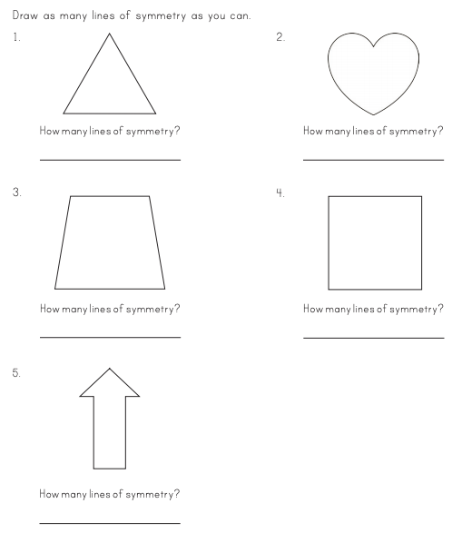

Activity 2

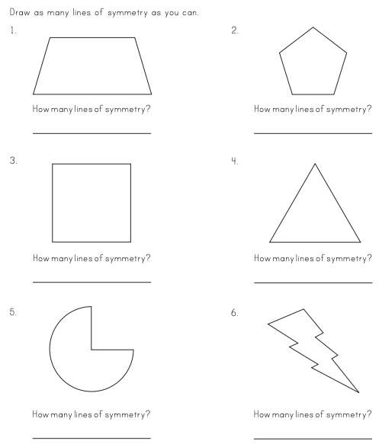

Activity 3

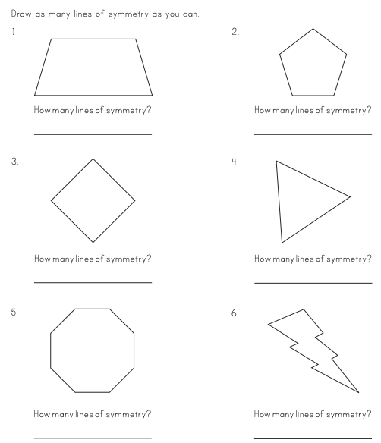

Challenge!

Below are some pictures that have been cut in half, you should try to imagine you have a mirror in the middle and draw the other half of the picture, so that it is symmetrical. There is also a blank for you to try your own!



