Spruce English

You have been working on inverted commas (speech marks) and speech. This week, it should all tie together.

Here is a link to the BBC Bitesize website:
https://www.bbc.co.uk/bitesize/articles/zb2wjhv

There is a song to help remember what inverted commas are, you can watch this if you like:

Watch this video on the page, it will give you reminders about inverted commas. 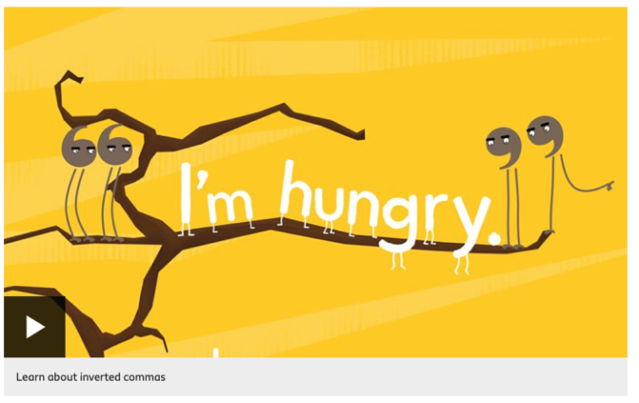

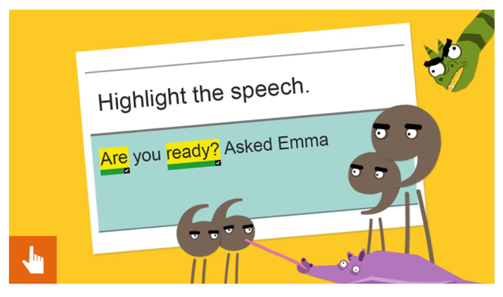
Then complete this activity.

Once you have done this there are some activities below. Choose one to complete.

Activity 1
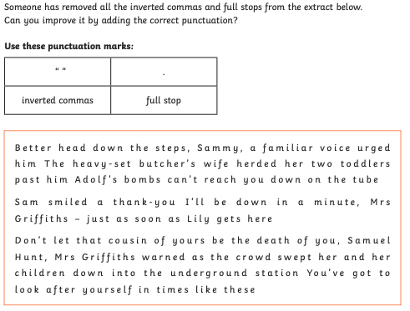

Activity 2
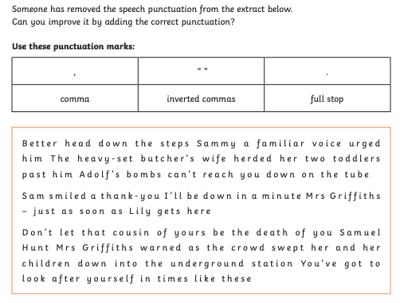

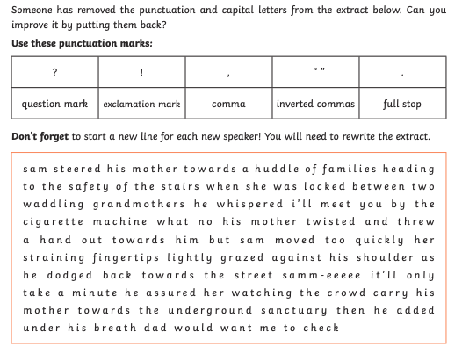
Activity 3



