Direct and Indirect Speech
Like the last few weeks, this week there are 3 English activities to choose from. Use the PowerPoint first then chose one of the activity pages. Start with the first if you find speech tricky, if you think you’re okay start with activity 2 and if you would like a challenge start with activity 3.

Activity 1

Decide whether the speech is direct or indirect.
Speech | Direct or indirect Speech?
William asked if he could have a turn on the slide.
‘It’s my turn next,” Shiya shouted.

Dad said that the children should stop arguing.
Kylie mentioned that the swings were free.

“I love the park,” squeaked Emir.

Mum told the children that it was time to go home.


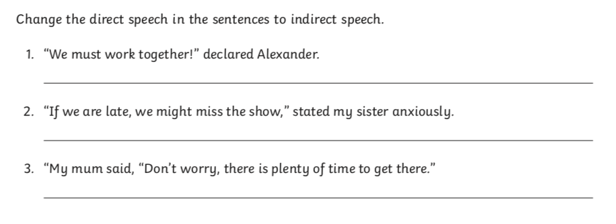

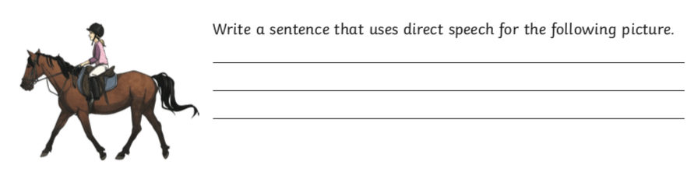

Activity 2

Decide whether the speech is direct or indirect.
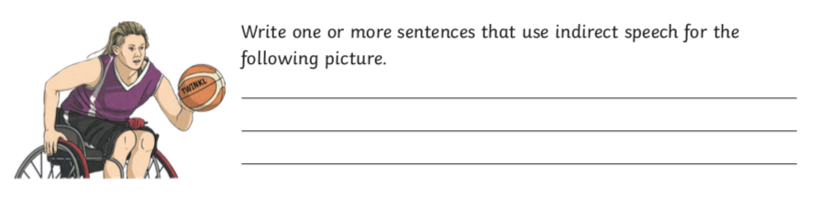
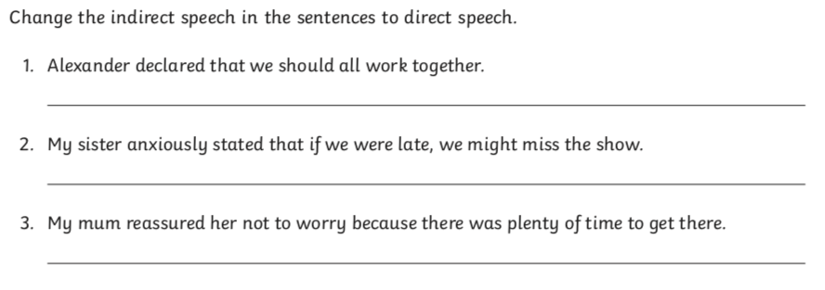
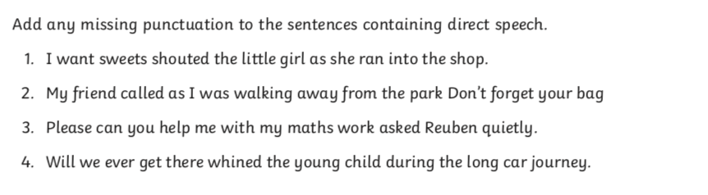
Speech | Direct or indirect Speech?
Nervously, William asked if he could have a turn on the slide.
“It’s my turn next,” Shiya shouted as she pushed past William.
“Stop pushing in. You always do that!” Jacob called angrily.
Dad said that the children should stop arguing and just enjoy playing together.
Kylie mentioned that the swings were free so maybe they should go on them instead.
‘I love the park,” squealed Emir as he toddled towards the swings.
Activity 3

Decide whether the speech is direct or indirect.

Speech | Direct or indirect Speech?
Nervously, William asked if he could have a turn on the slide as his sister played in the sandpit.
“It’s my turn next,” Shiya shouted as she pushed roughly past William.
Dad called out that the children should stop arguing and just enjoy playing together.
Kylie mentioned that the swings were free so maybe they should go on them instead of arguing about the slide.
‘I love the park,” squealed Emir as he toddled towards the swings.


