Watch the link below:

https://www.youtube.com/watch?v=7MlE4G8ntss

You can also use this link to an interactive Eat well plate: https://www.nhs.uk/live-well/eat-well/the-eatwell-guide/

Use the Eatwell plate to help you design a balanced meal! There is a blank plate on the page below, you can use this or draw your own!
Balanced Meal Activity


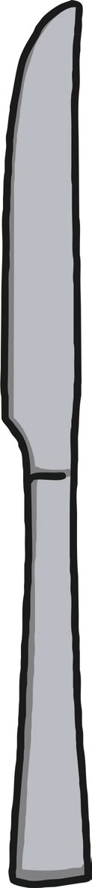
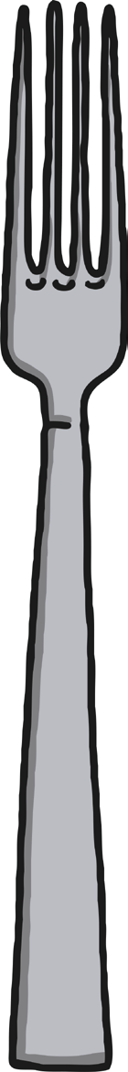
twinkl.com
twinkl.com
twinkl.com
twinkl.com
twinkl.com
twinkl.com
twinkl.com
twinkl.com
twinkl.com
twinkl.com
twinkl.com
twinkl.com
twinkl.com

