Spruce Maths Home Working Week Beginning 30.3.2020

Below are 3 sections of work. Start with section 1. As you work through the sections, they get harder, don’t worry if you can’t make it all the way, if you feel like a challenge work all the way to the end! At the bottom of the pack is some squared paper you might want to use to help answer the questions.

Section 1
Complete the table using the information in the bar chart.
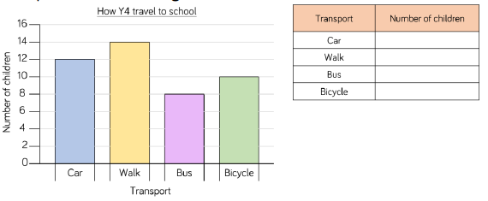

What is the most popular way to get to school?
What is the least popular way to get to school?
How many children walk to school?

Using the information below produce your own bar chart to show which games people are playing. You can print off the squared paper at the bottom of this pack or draw them on a sheet of your own paper. Use the PowerPoint to help you and think about the scale you could use.

Activities | Number of Children
Fortnite | 12
Animal Crossing | 7
Minecraft | 10
Roblox | 14
Super Mario | 6

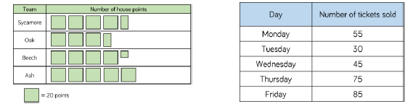
Represent the data in each table as a bar chart. Use the PowerPoint to help you. You can use the squared paper at the bottom of the pack

Section 2

Halifac City Football club sold the following number of season tickets  - Male adults – 6,382  - Female adults – 5,850  - Boys – 3,209  - Girls – 5,057  Would you use a bart chart, table or pictogram to represent this data?  Explain why. | Her is some information about the number of tickers sold for a concert.  Jack starts to create a bar chart to represent the number of concert tickets sold during the week.  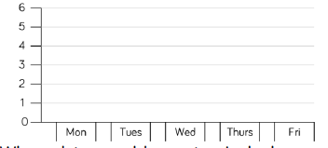  What advice would you give jack about the scale he has chosen?  What would be a better scale to use?  Is there anything else missing from the bar chart?
  Day | Number of tickets sold
  Monday | 55
  Tuesday | 30
  Wednesday | 45
  Thursday | 75
  Friday | 85
Alex wants to use a pictogram to represent the favourite drinks of everyone in her class.



Explain why this is not a good idea.

Section 3

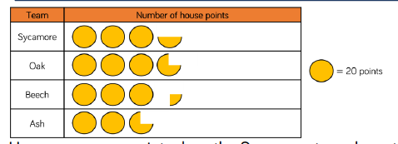
How many more points does the Sycamore team have than the Ash team?

How many points to Beech and Oak teams have altogether?

How many more points to Ashe need to be equal to Oak?

How many people voted in total?

¼ og the votes were for ……………

7 more people voted for ………….. than …………..

Favourite takeaway food | Number of votes
Fried chicken | 12
Burgers | 17
Fish and chips | 21
Kebab | 9
Pizza | 14
Use the data to create a pictogram.
You could use the template below or create your own.

Once you have finished can you create your own questions that could be asked about the data?
Rosie says:
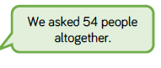

Can you spot Rosie’s mistake?

How many people were asked altogether?

True or False?

- The same number of people visited Maltings Castle as Film Land Cinema on Saturday.
- Double the number of people visited Animal world Zoo on Sunday than Saturday.

- The least popular attraction of the weekend was Primrose Park.



