Islam and the Qu’ran

In Learning Quest this half term, we will be learning about Islam, the Prophet Muhammad and the Qu’ran.

To get started, watch the two videos posted below.

https://www.bbc.co.uk/bitesize/clips/z4fgkqt

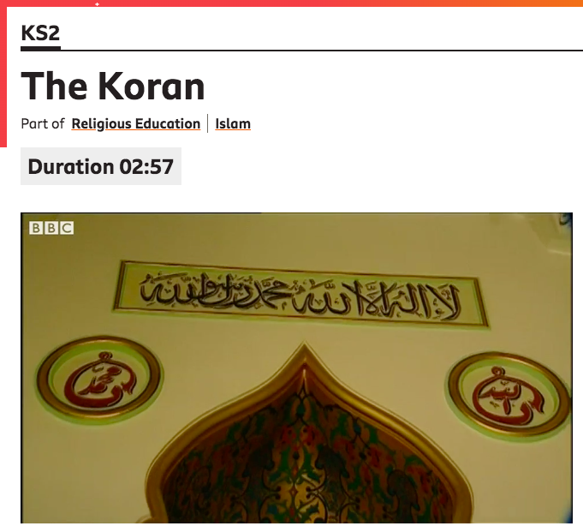

https://www.bbc.co.uk/bitesize/clips/zrn34wx

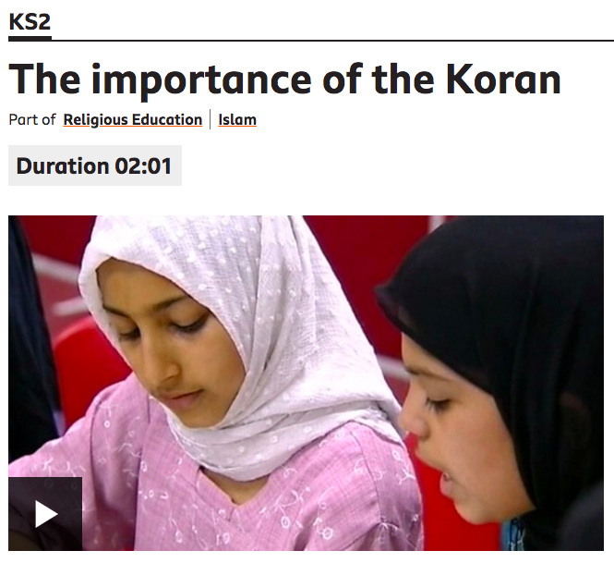

Do you have any books in your life (Holy or non-Holy) that are important to you?

What book is it?

How did you get this book?

What makes it so important to you?

Have a conversation with an adult about the videos you watched and your treasured book.

