Self-assessment


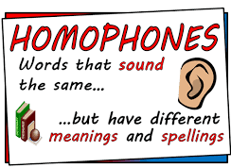
Match each of these words to the homophones below.
Be Blue Bare Steal
To Flour High Meet
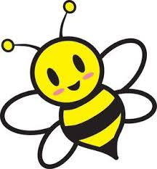
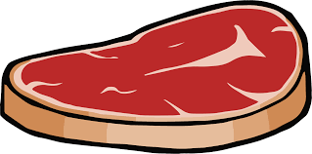

Meat >

Bee >


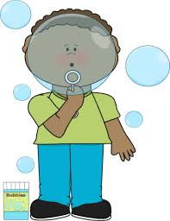

Hi >

Blew >


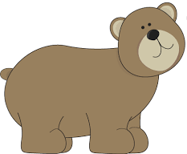

Bear >

Flower >



Steel >

Two >

Write a sentence using the right homophones for each picture.

____________________________________________________________________
____________________________________________________________________
____________________________________________________________________

_______________________________________________________________
_______________________________________________________________
_______________________________________________________________

_______________________________________________________________
_______________________________________________________________
______________________________________________________________

_______________________________________________________________
_______________________________________________________________
_______________________________________________________________

Challenge: How many different homophones can you find?

