Growth mindset

Click on the links below to learn more about growth mindset.

What is a good mistake?

https://www.bbc.co.uk/teach/class-clips-video/pshe-ks2-growth-mindset-what-is-a-good-mistake/zd9c6v4

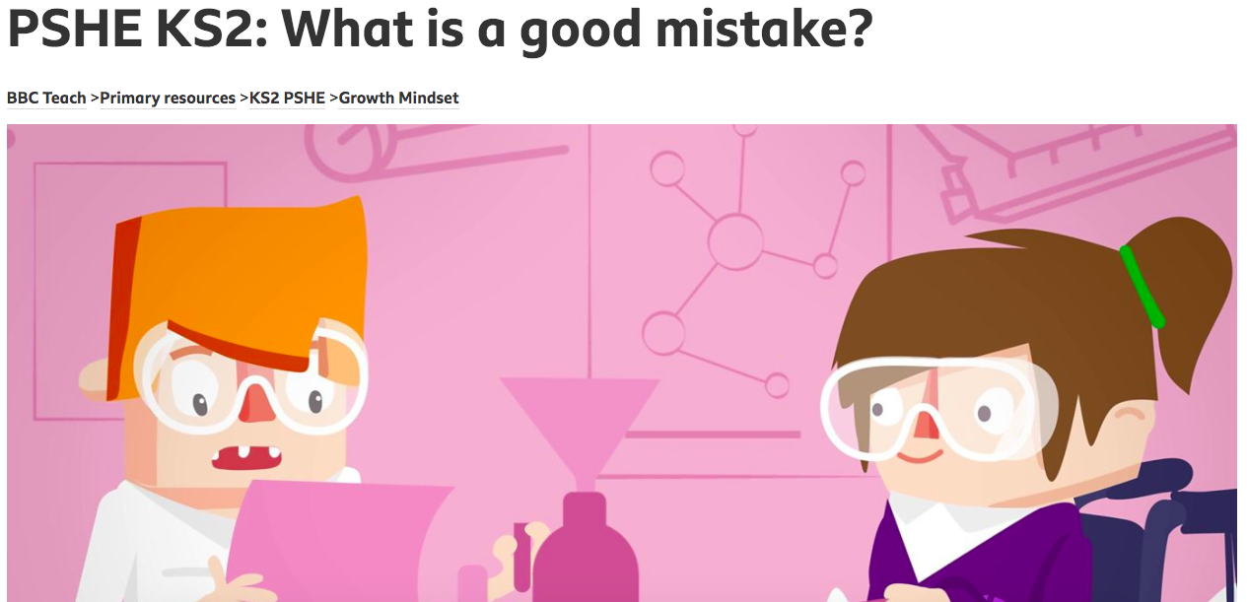

How your mindset can affect your approach to challenges

https://www.bbc.co.uk/teach/class-clips-video/pshe-ks2-growth-mindset-how-your-mindset-can-affect-approach-to-challenges/zrjwf4j

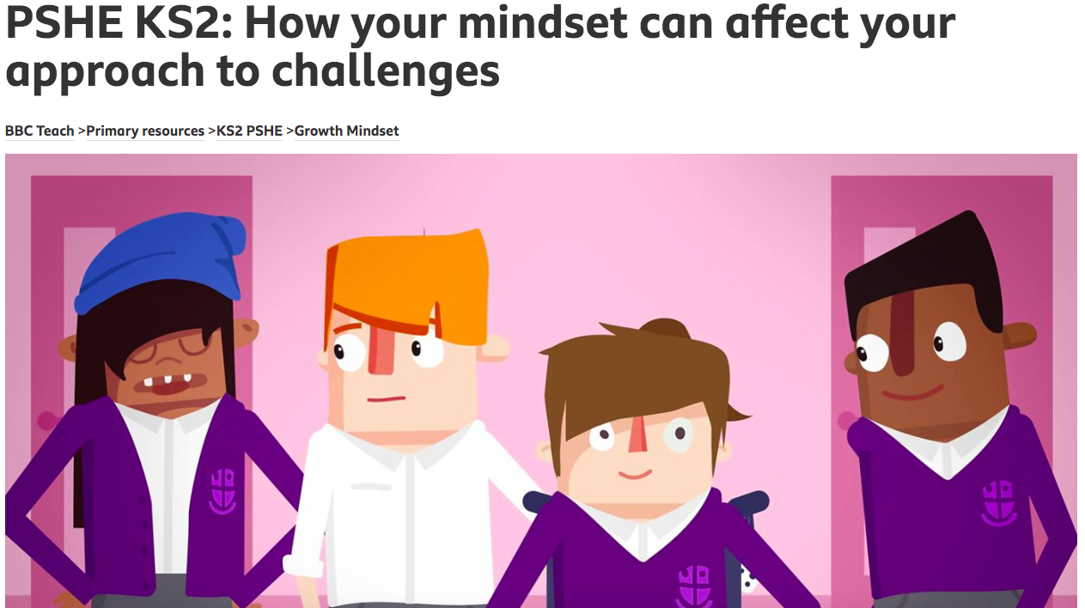

How to develop a positive mindset

https://www.bbc.co.uk/teach/class-clips-video/pshe-ks2-growth-mindset-how-to-develop-a-positive-mindset/z6gb2sg



