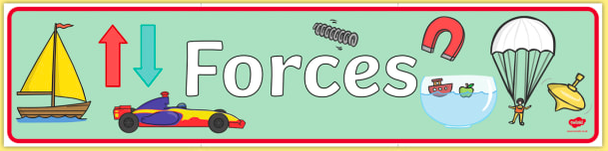

Gravity
Watch the videos on YouTube and BBC Bitesize to learn more about gravity:

https://www.youtube.com/watch?v=ljRlB6TuMOU

https://www.bbc.co.uk/bitesize/topics/z4brd2p/articles/zr3xh39

Write down any questions you might have about gravity and we can talk about them when you come back to school!

Read the poem a few times and see if it helps you to remember some gravity facts.
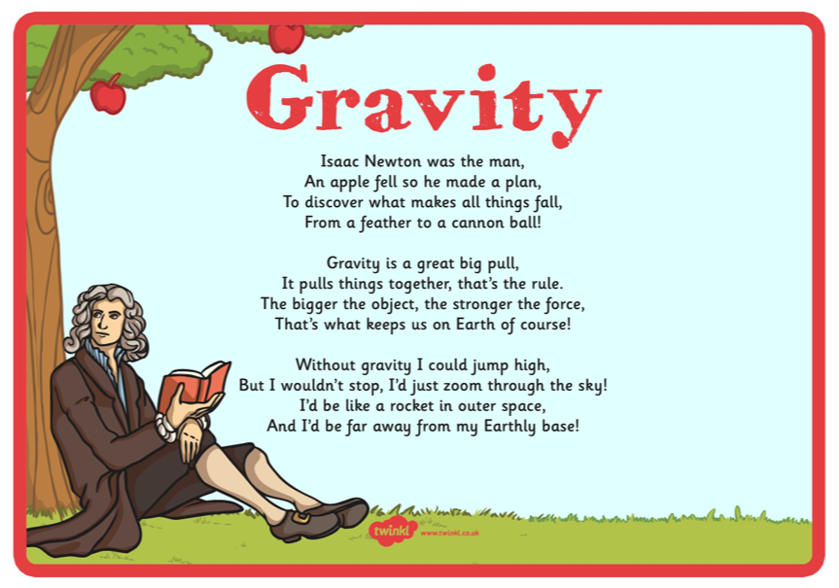
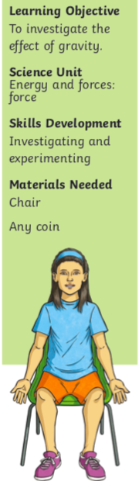Now try these activities to investigate gravity.

- Sit on a chair and ask someone to put a finger on your forehead. Can you stand up?

- Stand with your back up against a wall. Put a coin about 30cm away from you on the floor. Can you pick the coin up without falling over?

- Stand with your feet apart facing a wall and ,make sure your head, shoulders and feet are touching the wall. Now try to lift a leg.

What is happening? Why is this happening?

It is not possible to do any of the challenges: to get off the chair, pick up the coin or lift a leg.
To keep your balance, you must keep your centre of gravity above your legs. The centre of gravity of an object is the point where all its weight acts. Your body’s centre of gravity is located about 4cm below the navel. To get off the chair, you must lean forward to get your centre of gravity above your legs. As you bend down in challenge 2, your centre of gravity moves forward and you become unbalanced. In the last challenge, to lift your leg, you must lean forward to move your centre of gravity.

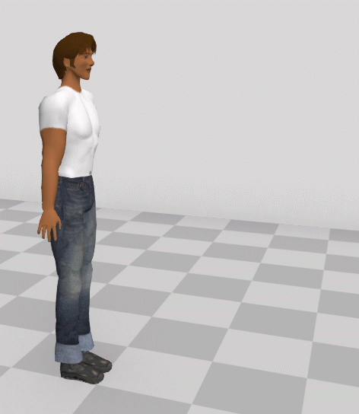

Now, try them on someone else!

