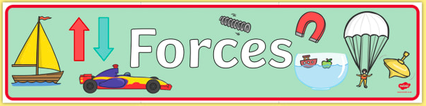

Friction

First, look at the PowerPoint presentation to introduce you to friction.
Next, watch the video on BBC Bitesize to learn more about friction:

https://www.bbc.co.uk/bitesize/topics/zsxxsbk/articles/zxqrdxs

Now look at the investigations below. Before you attempt them, see if you can guess what will happen. Use the powerpoint and video to help you make a sensible prediction.

Once you have completed the activities, record your ideas in any way you like - try to use a different method to last week.

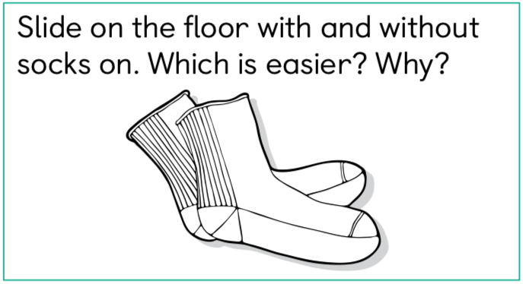

Before you try the activities, check that it is ok with your grownups, make sure you have plenty of room around you and be safe!

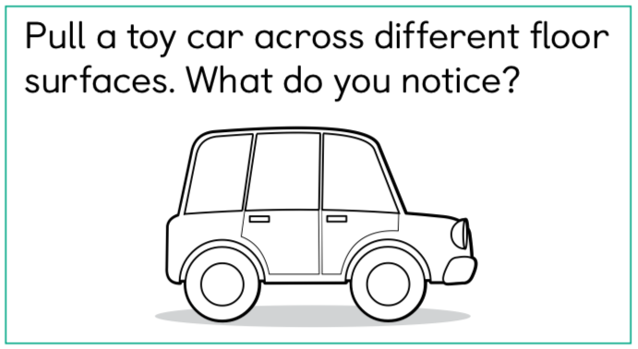

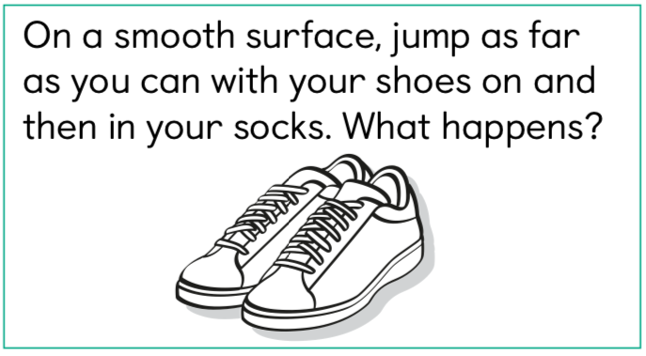

Before you try the activities, check that it is ok with your grownups, make sure you have plenty of room around you and be safe!

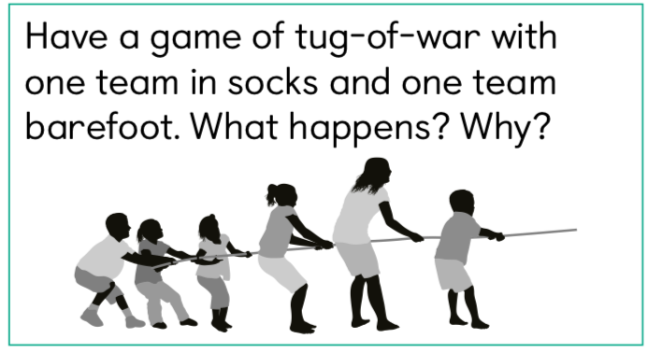Don’t worry if you don’t have a team, you only need two people!

Optional Challenge Questions:



