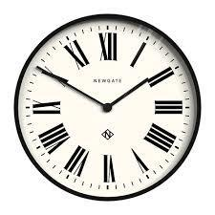
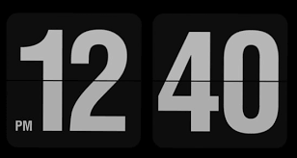







Addition
Multiplication
Money

Time

Subtraction

Sticky Skills and Knowledge
Division
Maths

At Fern House School we place emphasis on the key skills and essential knowledge to succeed at school and in the wider community. Our ‘sticky skills and knowledge’ are often the basis of other skills and knowledge and with these sticky skills we feel our pupils will have the foundations to be independent and successful learners and be better equipped to achieve their short term goals within school and their long term goals after leaving Fern House.

